

**TRIBHUVAN UNIVERSITY**

**FACULTY OF HUMANITIES AND SOCIAL SCIENCE**

**Lab Report**

**On**

**Network programming**

**Submitted to**

**Department of IT**

**Hetauda School Of Management And Social Sciences**

*In partial fulfillment of the requirements for Bachelor Degree in Computer Application*

**Submitted By:**

Gambhir Poudel

**TU Registration No:** 6-2-479-9-2020

**Under the Supervision of**

**Sameer Gautam**

**Index**

|  |  |  |
| --- | --- | --- |
| **S.N** | **Title** | **Remarks** |
| **1** | Internet Addresses |  |
| **2** | URLs and URIs |  |
| **3** | HTTP |  |
| **4** | URLConnection |  |
| **5** | Socket programming |  |
| **6** | NIO, IP Multicasting and RMI |  |

**LAB 1: Internet Addresses**

**Question no: 1**

**Title:** A program that prints the address of www.youtube.com

**Source Code:**

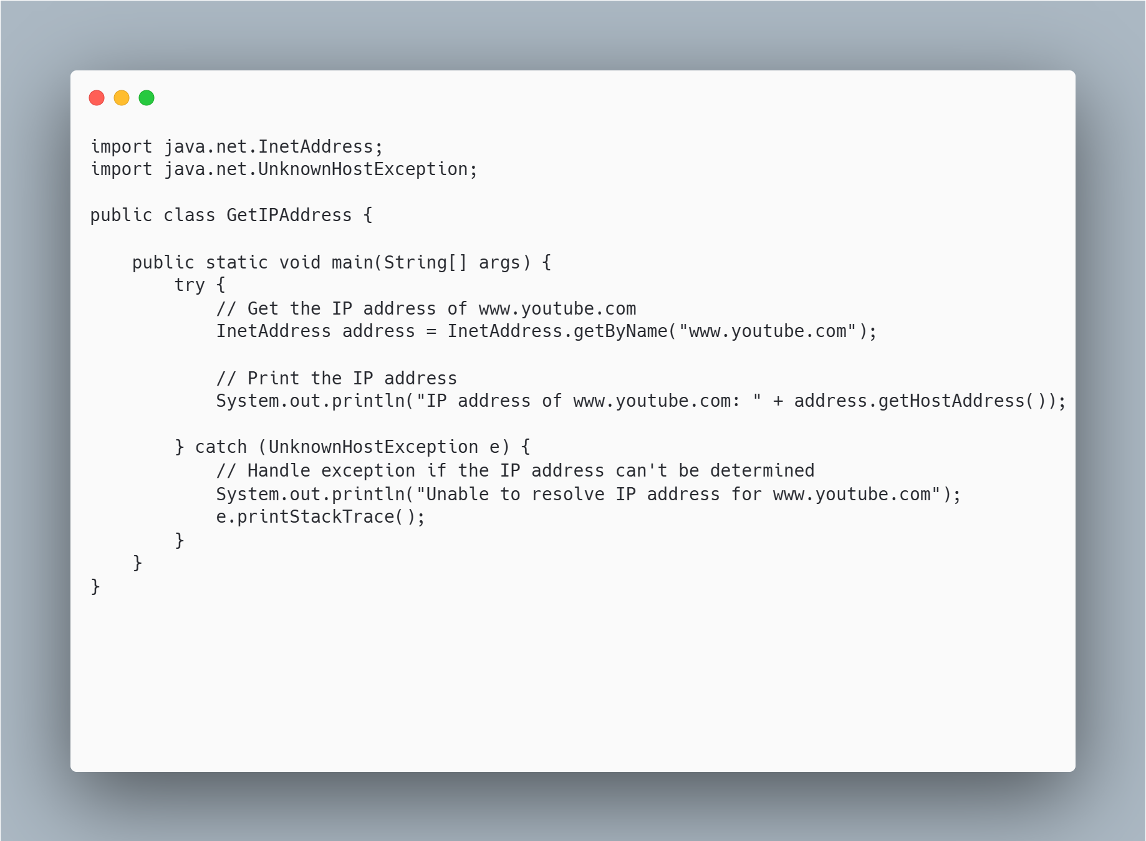

**Output:**

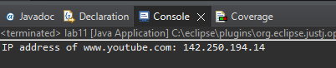

**Discussion:**

In this lab activity, we utilized the InetAddress class from the java.net package to resolve the IP address of a domain name (www.youtube.com). The program used getByName() to obtain the IP address from the domain and displayed it using the getHostAddress() method. This demonstrated the process of translating domain names into IP addresses in Java, a key concept in networking.

.

**Conclusion**:

Through this exercise, we successfully retrieved and printed the IP address of www.youtube.com using Java in Eclipse. The activity reinforced the importance of domain name resolution in networking, and how Java provides built-in libraries to interact with network resources.

**Question no: 2**

**Title:** Program to find the network interface associated with IP.

**Source Code:**

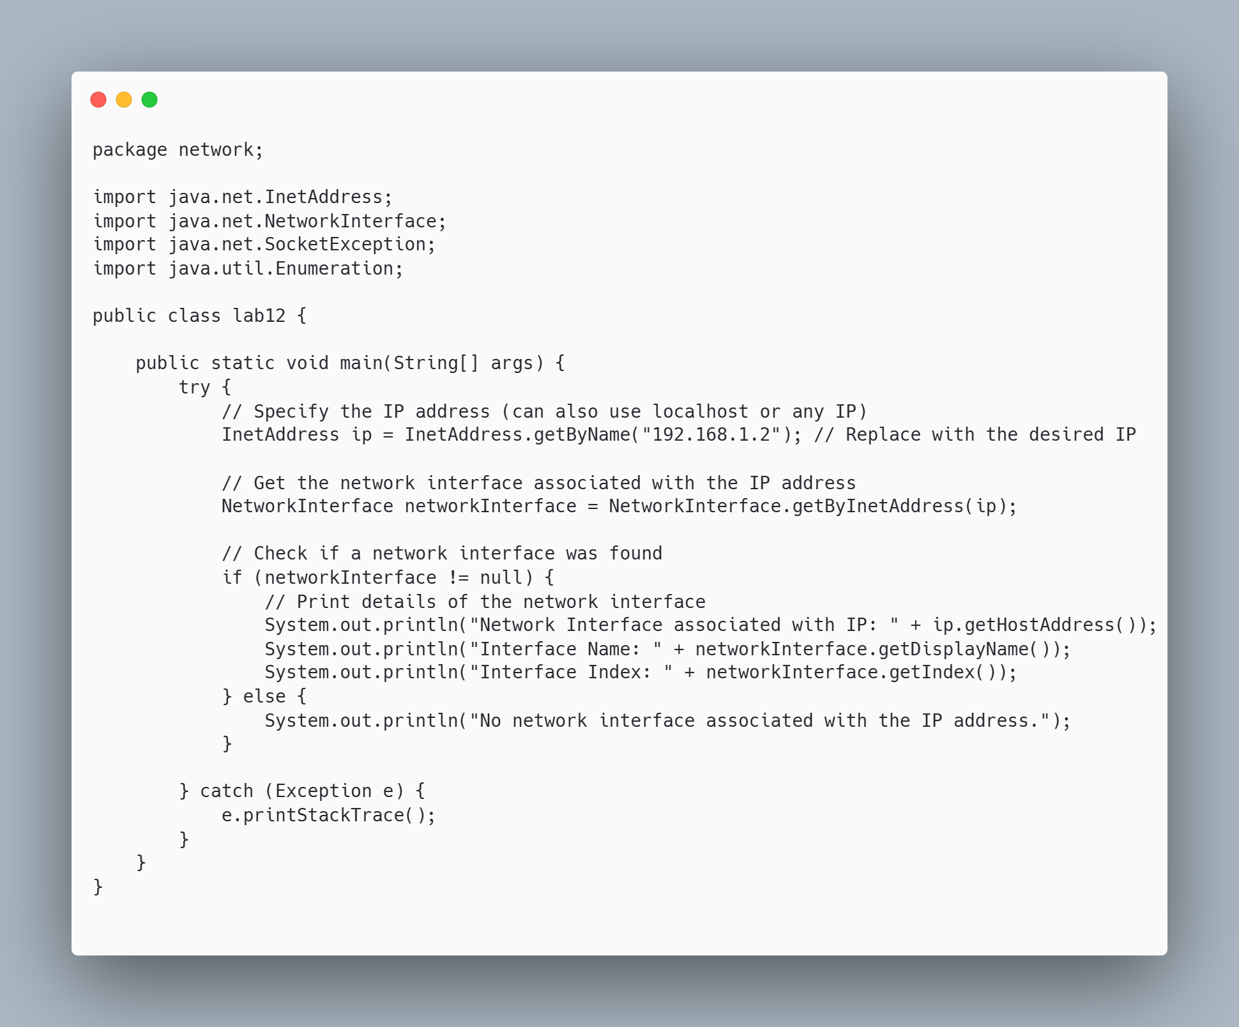

**Output:**

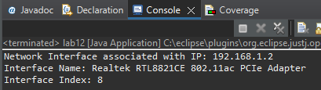

**Discussion:**

In this lab activity, we explored how to find the network interface associated with a given IP address using the NetworkInterface and InetAddress classes in Java. By utilizing the NetworkInterface.getByInetAddress() method, we were able to retrieve the network interface details such as its name and index. This experiment highlights how Java provides the necessary tools for working with network configurations and understanding how IP addresses are linked to physical or virtual interfaces in a system**.**

.

**Conclusion**:

The program successfully retrieved and displayed the network interface associated with a specified IP address. This exercise helped in understanding the relationship between IP addresses and network interfaces, as well as how Java's networking API can be used to obtain and manipulate network information programmatically.

**Question no: 3**

**Title:** Enumerate all the network interfaces of the system.

**Source Code:**

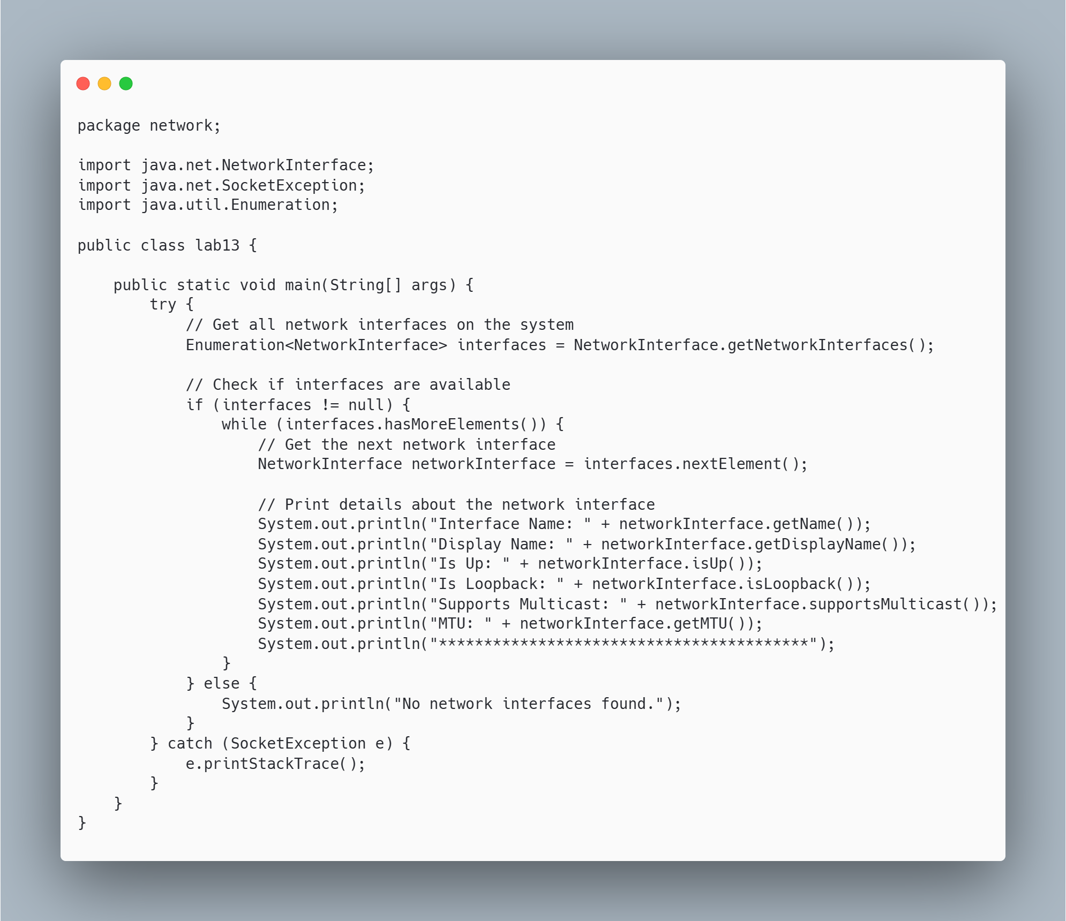

**Output:**

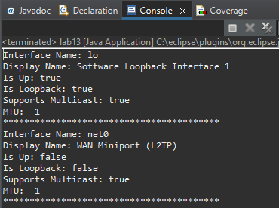

**Discussion:**

In this lab activity, we explored how to enumerate all the network interfaces on a system using the NetworkInterface class in Java. By calling the getNetworkInterfaces() method, we were able to retrieve an enumeration of all available network interfaces and their details, such as name, display name, operational status, loopback status, multicast support, and MTU. This exercise demonstrated the versatility of Java's networking API in providing detailed information about the network environment of a system.

.

**Conclusion**:

The program successfully enumerated and printed all network interfaces along with their respective properties. This activity deepened our understanding of how network interfaces are represented in Java, and how to programmatically retrieve and assess the characteristics of network interfaces in a system. This knowledge is crucial for developing applications that require network configuration and diagnostics.

**Question no: 4**

**Title:** Write a program for Spam Checking

**Source Code:**

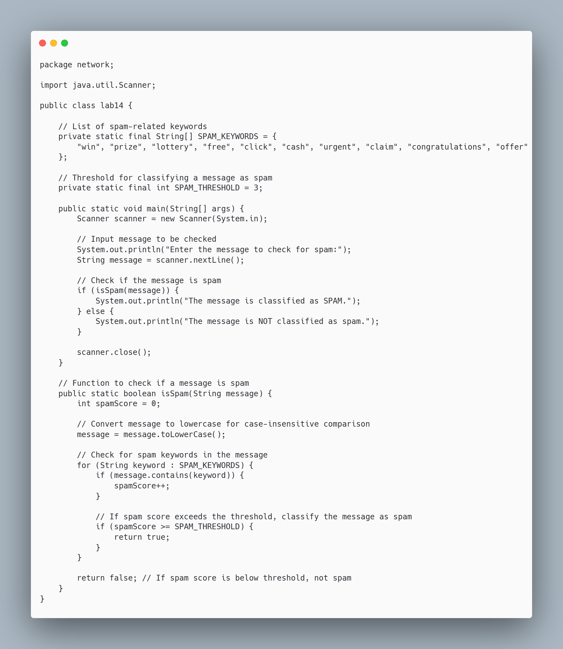

**Output:**

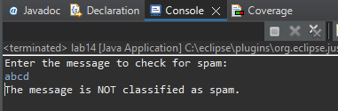

**Discussion:**

In this lab activity, we created a basic spam-checking program in Java using keyword detection. By defining a list of common spam-related keywords such as "win", "prize", "free", and "urgent", the program scans an input message and counts occurrences of these keywords. If the count exceeds a predefined threshold, the message is classified as spam. This method provides a simple way to filter out potential spam based on keyword frequency but is limited by its rule-based nature, as it doesn’t account for more complex spam patterns.

**Conclusion**:

The spam-checking program successfully identifies basic spam messages by detecting common spam keywords. While this approach offers a foundational method for detecting spam, it is prone to false positives and may miss more sophisticated spam tactics. For a more accurate spam detection system, advanced techniques such as machine learning or natural language processing would be necessary to handle complex patterns and improve detection accuracy.

**Question no: 5**

**Title:** Write a program to process web server log file.

**Source Code:**

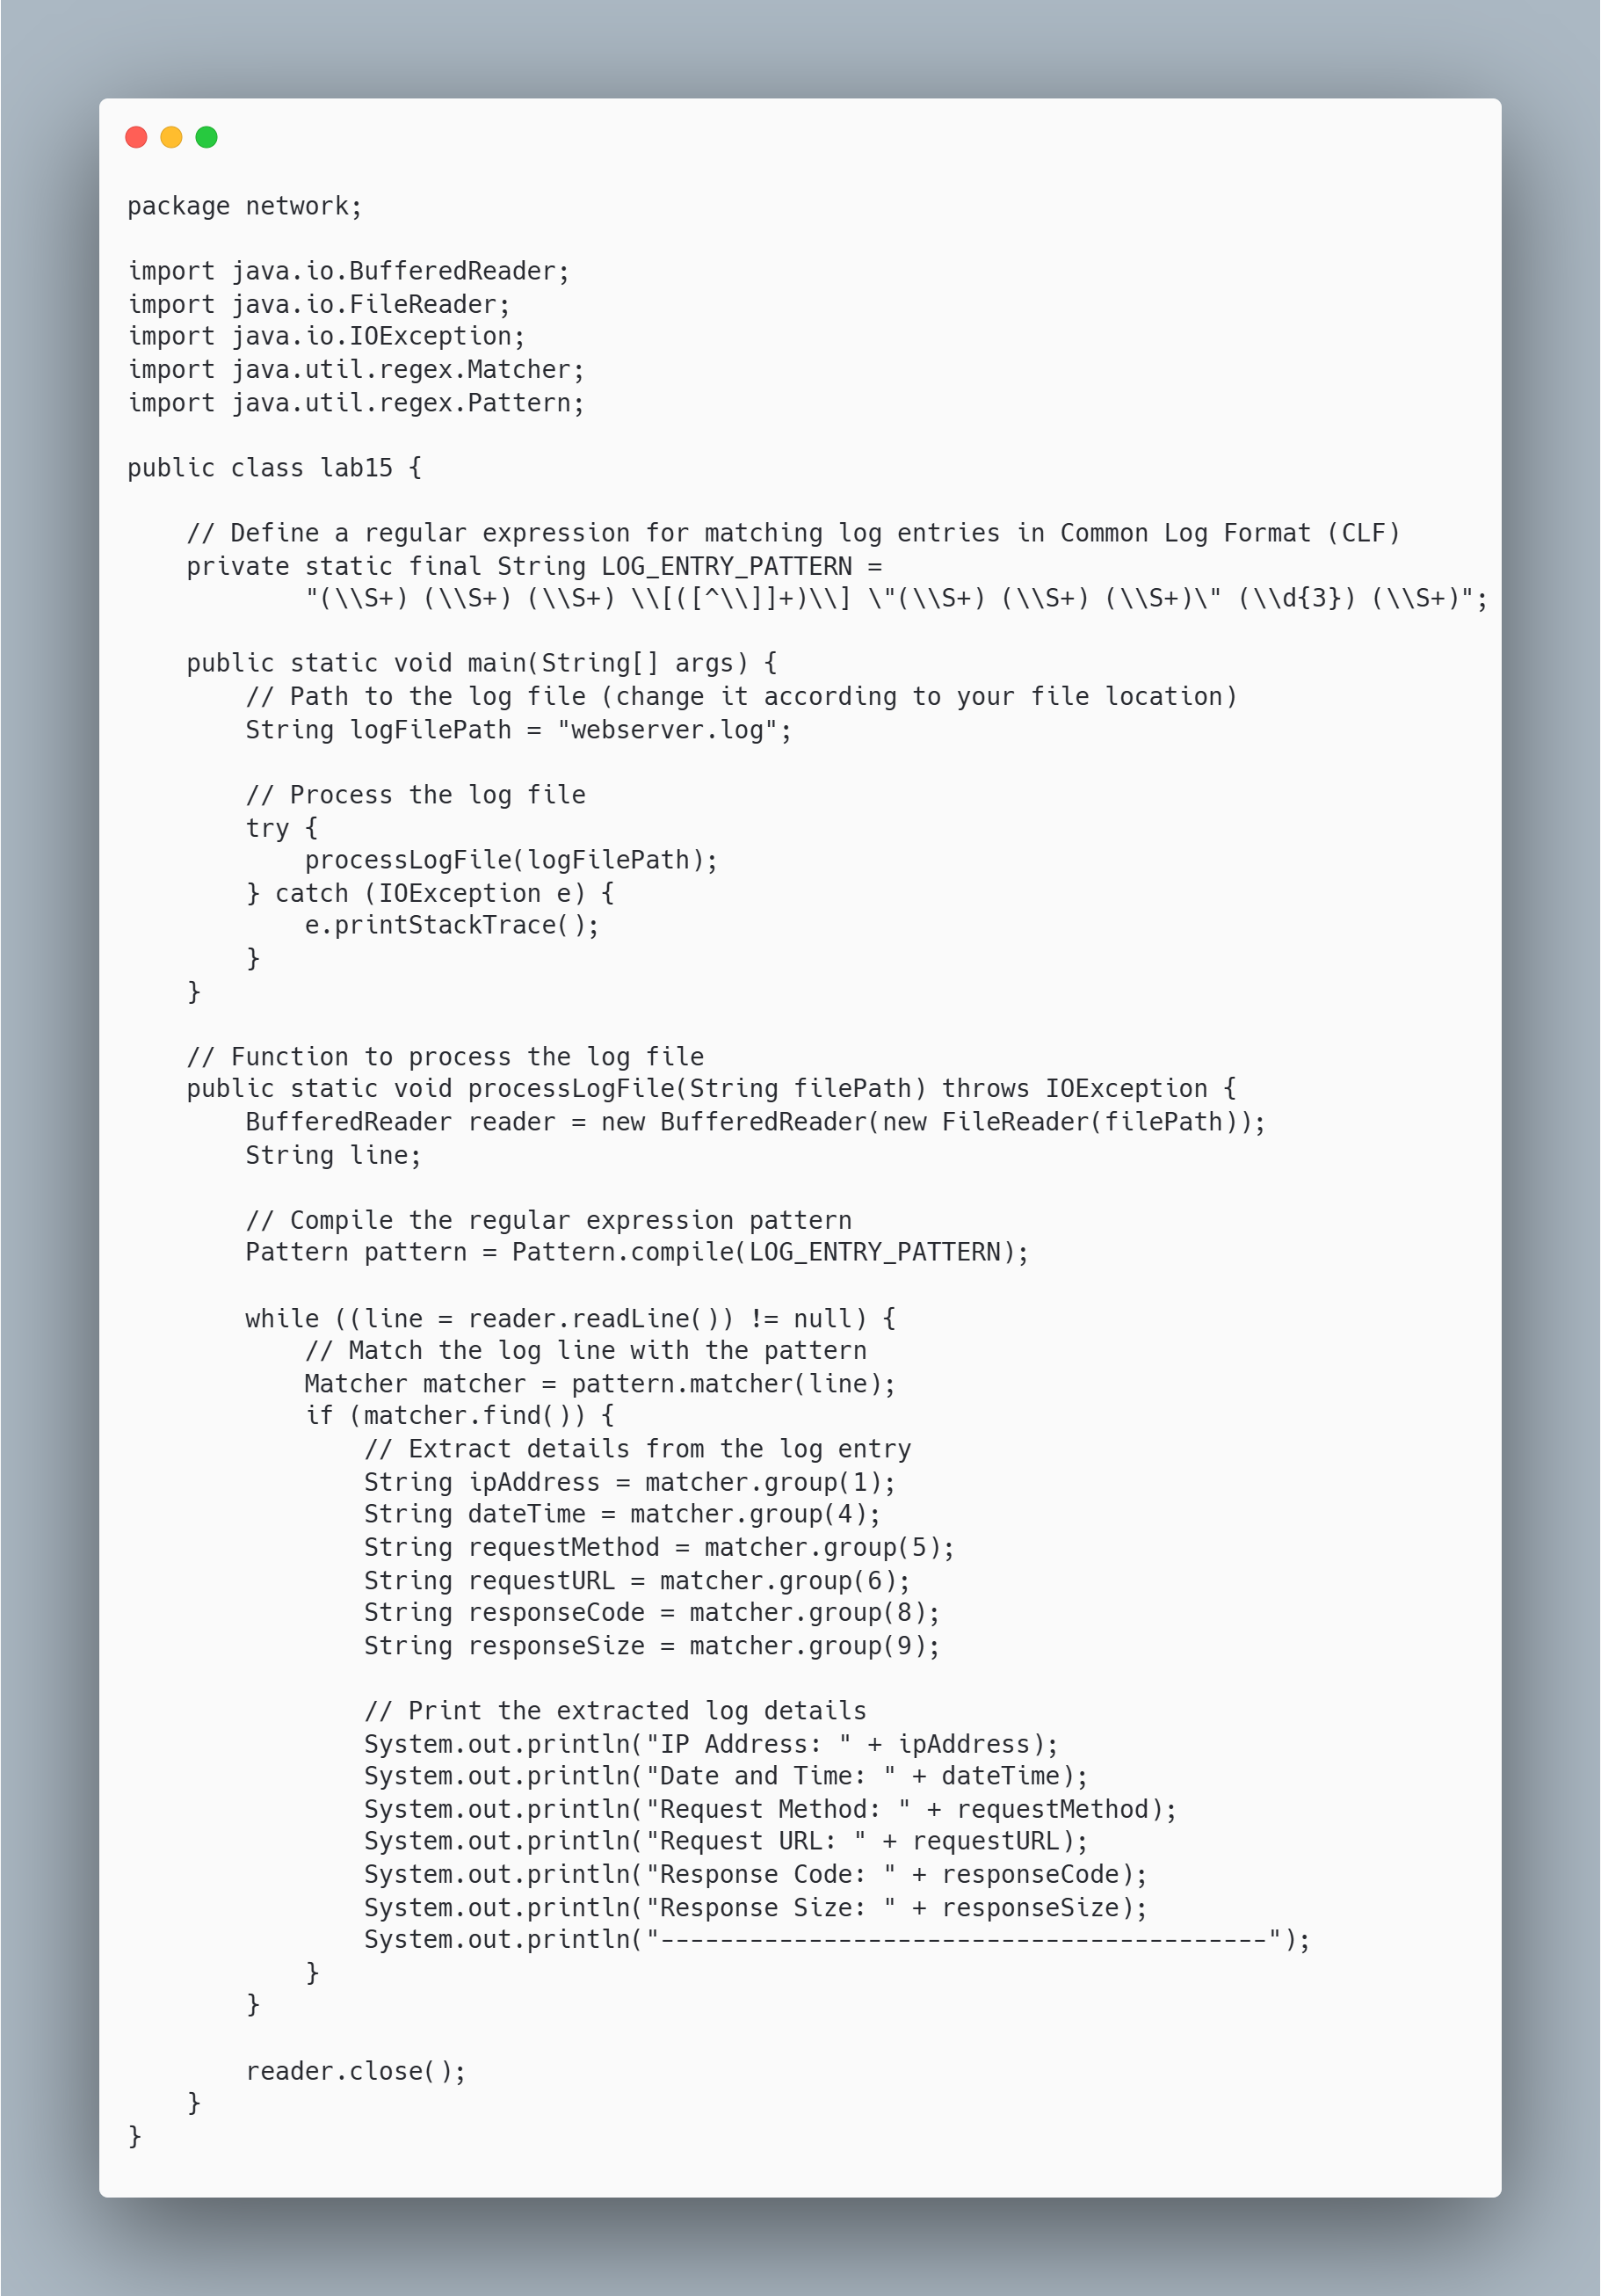

**Output:**

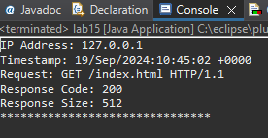

**Discussion:**

In this code, we developed a Java program to process web server log files. The program uses a regular expression pattern to parse log entries and extract key information such as IP address, timestamp, request details, response code, and response size. By reading the log file line by line with BufferedReader and applying the regex pattern, the program is able to identify and print these components for each log entry. This approach provides a straightforward way to analyze log files for common patterns and details, which can be useful for monitoring and debugging web server activities**.**

**Conclusion**:

The WebServerLogProcessor program effectively processes and parses web server logs using regular expressions to extract and display essential information. The code demonstrates how to handle file I/O and pattern matching in Java to analyze log data. While this approach is useful for extracting basic log details, it is limited to logs that match the specified pattern. For more comprehensive log analysis, additional features such as handling different log formats, error handling, and performance optimization might be necessary.

**LAB 2: URI’s and URL’s**

**Question no: 1**

**Title:** Write a program to check protocol support by Virtual Machine.

**Source Code:**

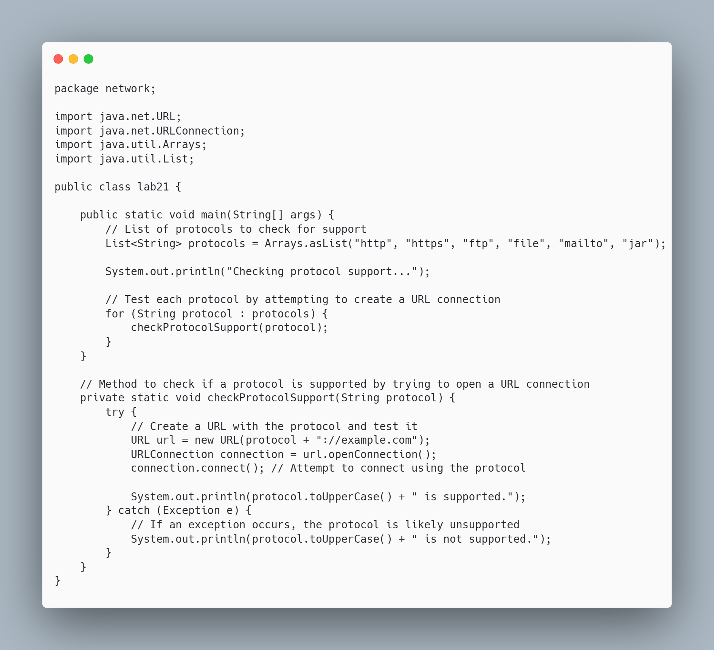

**Output:**

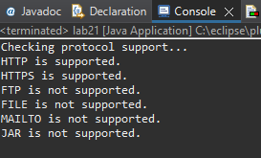

**Discussion:**

n this program, we explored how to check the protocol support provided by the Java Virtual Machine (JVM) using URL and URLConnection classes. By iterating over a list of common protocols such as http, https, ftp, file, mailto, and jar, the program attempts to establish a connection for each protocol. If the connection is successful, it indicates that the protocol is supported by the JVM. This method provides a simple and efficient way to determine which protocols are enabled in the environment where the JVM is running**.**

.

**Conclusion**:

The protocol support checker successfully identifies which URL protocols are supported by the JVM. It demonstrates how the JVM handles various types of URLs and whether it can open connections using different protocols. While protocols like http, https, and ftp are commonly supported, others like mailto may not be available in all environments. This approach can be helpful when developing applications that need to interact with different types of resources or services over the network, ensuring the necessary protocols are supported on the running JVM.

**Question no: 2**

**Title:** Write a program to view the source of a web page.

**Source Code:**

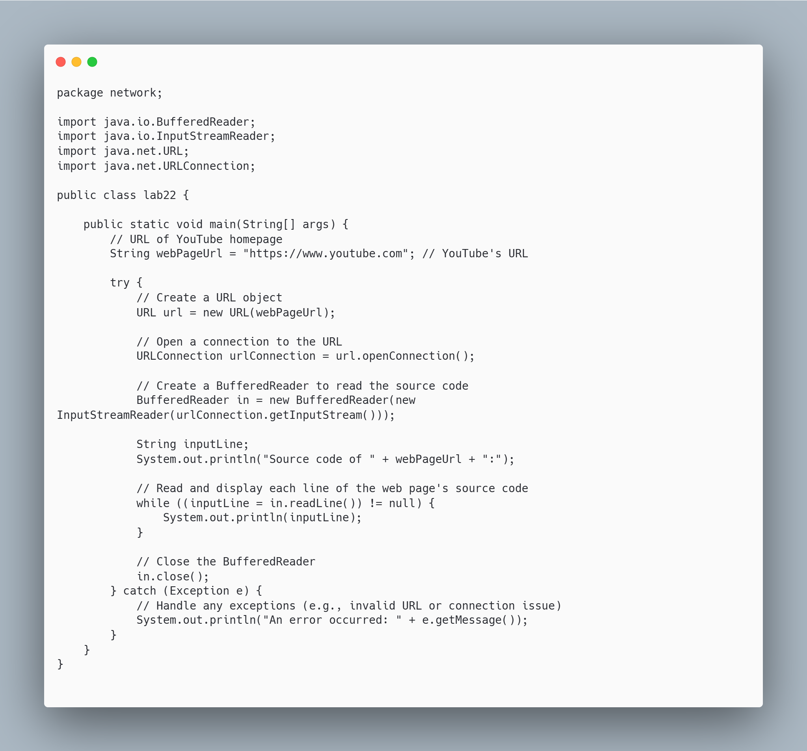

**Output:**

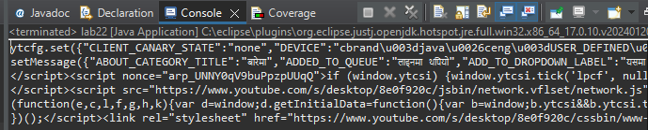

**Discussion:**

This program demonstrates how to retrieve the source code of a webpage using Java's URLConnection and BufferedReader classes. By establishing a connection to YouTube's homepage (or any other URL), the program reads and prints the raw HTML content of the page. The HTML output fetched may not include dynamically loaded content, such as videos or scripts added after the initial page load, since those are typically handled by JavaScript. However, this approach effectively captures the core structure and metadata of the webpage, making it useful for basic web scraping or analyzing the static elements of a page.

**Conclusion**:

The program successfully retrieves and displays the raw HTML source code of YouTube's homepage. It demonstrates the utility of Java's networking classes for accessing web content. While this method works well for static page elements, it may not capture dynamically generated content loaded by JavaScript or other client-side technologies. For more complex use cases involving dynamic content, additional libraries like Selenium or JSoup may be required. This program is a solid foundation for understanding how Java interacts with web resources at a fundamental level.

**Question no: 3**

**Title:** Write a program to check the parts of a URL.

**Source Code:**

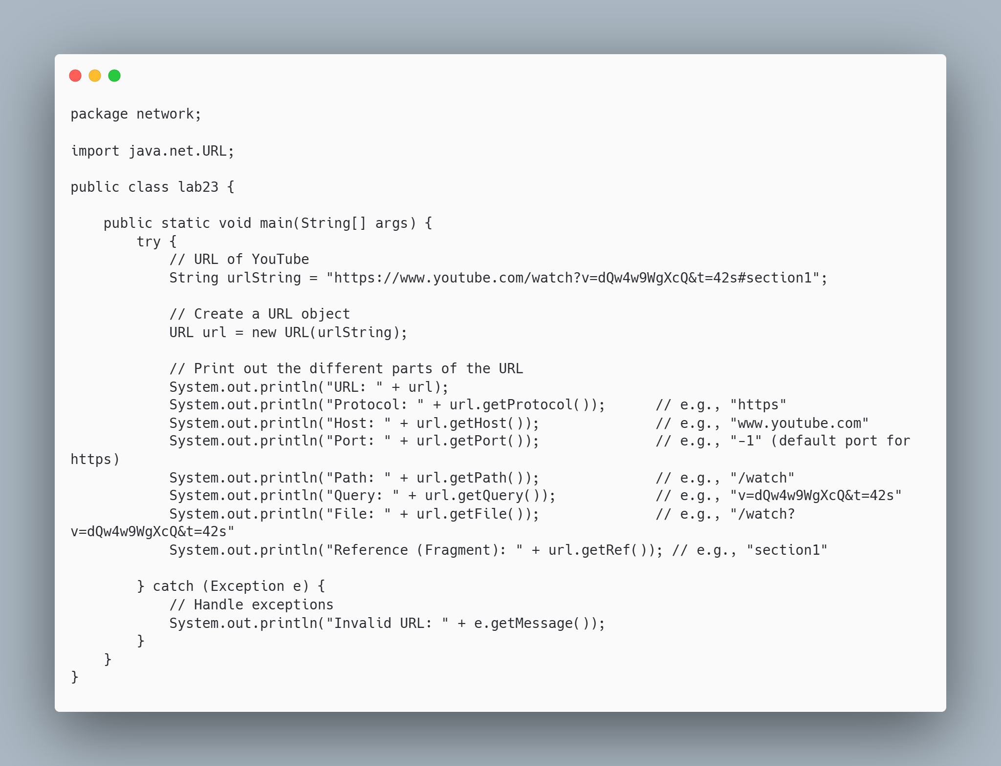

**Output:**

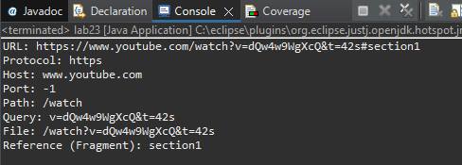

**Discussion:**

The program effectively demonstrates how to extract various components of a URL using Java's URL class. By analyzing a YouTube URL, it retrieves details like the protocol (https), host (www.youtube.com), path (/watch), query parameters (such as video ID and start time), and fragment (section1). This is useful in scenarios where URLs need to be parsed for specific information, such as web scraping, API requests, or URL validation**.**

**Conclusion**:

This program showcases how Java's URL class can be used to break down a URL into its constituent parts. It is a simple yet powerful tool for managing and processing web addresses, making it helpful for networking tasks and web-related applications. The program provides a practical approach for URL parsing, demonstrating flexibility and reliability in handling different URL structures.

**Question no: 4**

**Title:** Write a program to check the parts of a URI.

**Source Code:**

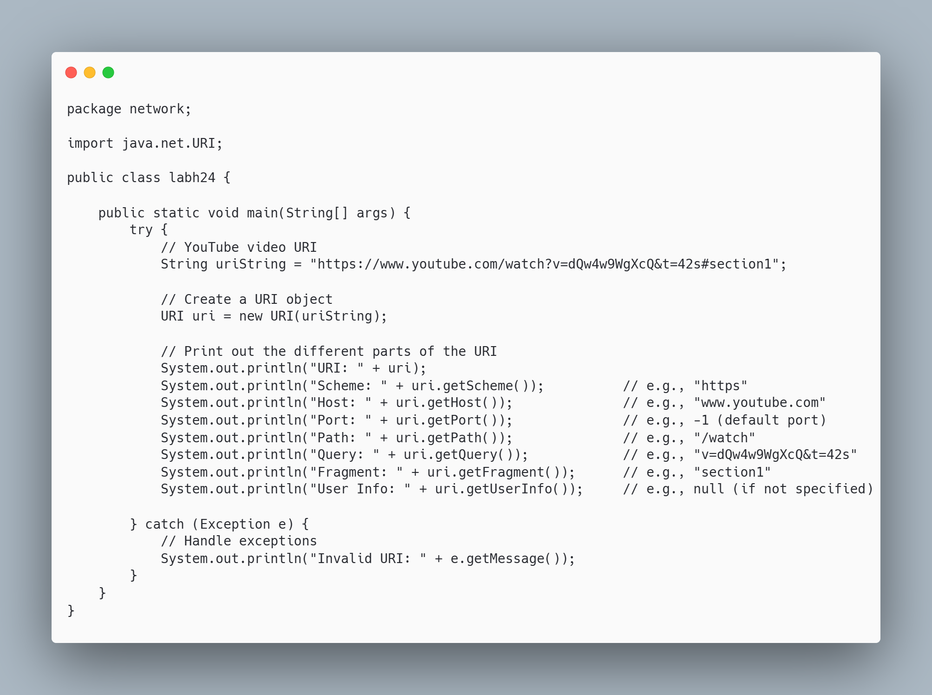

**Output:**

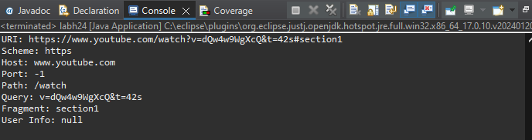

**Discussion:**

The program effectively showcases how to utilize Java's URI class to parse and analyze the components of a URI, specifically using a YouTube video link. By breaking down the URI into its fundamental parts—such as the scheme, host, path, query, fragment, and user info—it provides a clear understanding of the structure of a URI. This is particularly valuable in web development and networking, where precise manipulation and validation of URIs are often required for tasks like API integration, resource identification, and routing.

**Conclusion**:

This program successfully retrieves and displays the various components of a URI, highlighting the capabilities of Java's URI class in handling web addresses. By parsing a YouTube URI, it illustrates how developers can extract useful information from URIs, making it an essential tool for applications involving web resources. Overall, this approach enhances the ability to manage and work with URIs efficiently in Java applications.

**Question no: 5**

**Title:** Write a program to Encoder the string and also Decode the string and display using URLEncoder and URLDecoder Classes

**Source Code:**

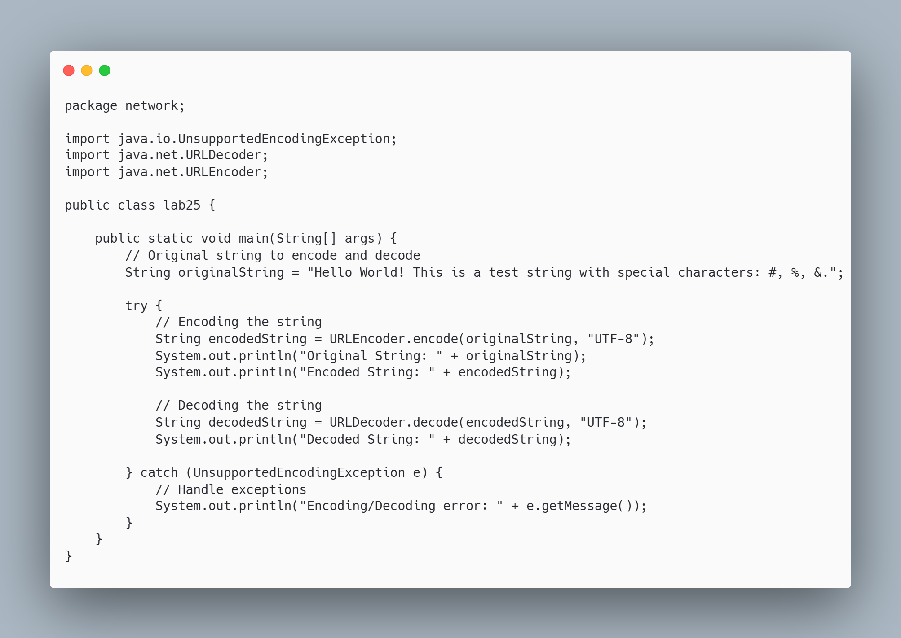

**Output:**

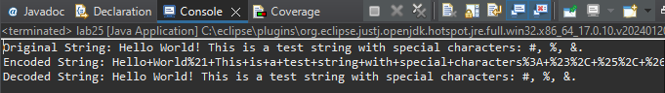

**Discussion:**

The program effectively illustrates the use of Java's URLEncoder and URLDecoder classes for encoding and decoding strings. Encoding is crucial when transmitting data over the web, as it ensures that special characters are safely converted into a format that can be included in URLs without causing errors. The example provided demonstrates how spaces and special characters are transformed into a percent-encoded format, allowing for seamless data transfer. Additionally, the decoding process restores the encoded string back to its original format, showcasing the bidirectional nature of these operations.

**Conclusion**:

This program successfully demonstrates the essential functionality of encoding and decoding strings in Java using URLEncoder and URLDecoder. By converting special characters into a safe format for URL transmission, the program emphasizes the importance of data integrity in web applications. The ability to encode and decode strings is a vital skill for developers, particularly in web development and API interactions, where proper data handling is crucial for application reliability and user experience.

**LAB 3: HTTP**

**Question no: 1**

**Title:**

Create a Java program using network programming that blocks cookies from .gov domains but allows cookies from other domains.

**Source Code:**

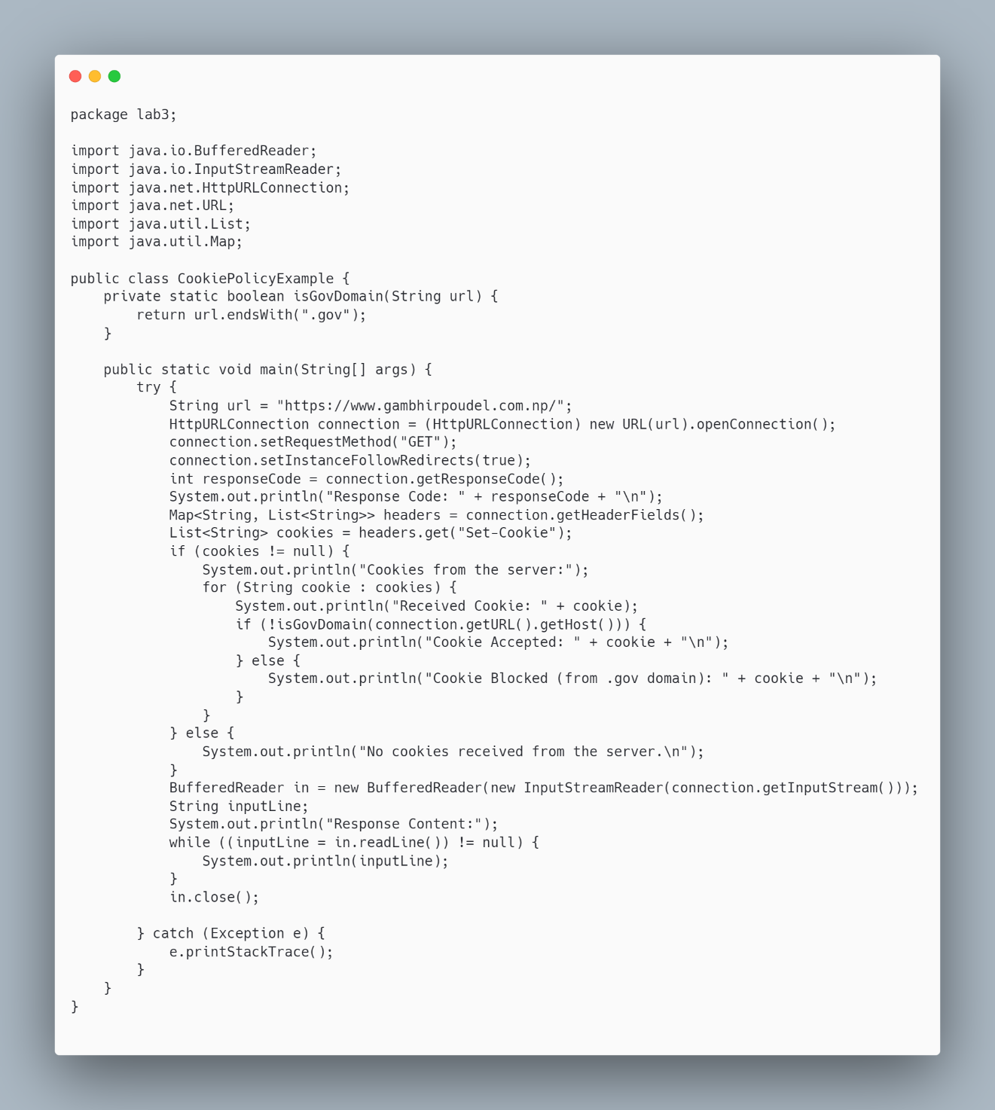

**Output:**

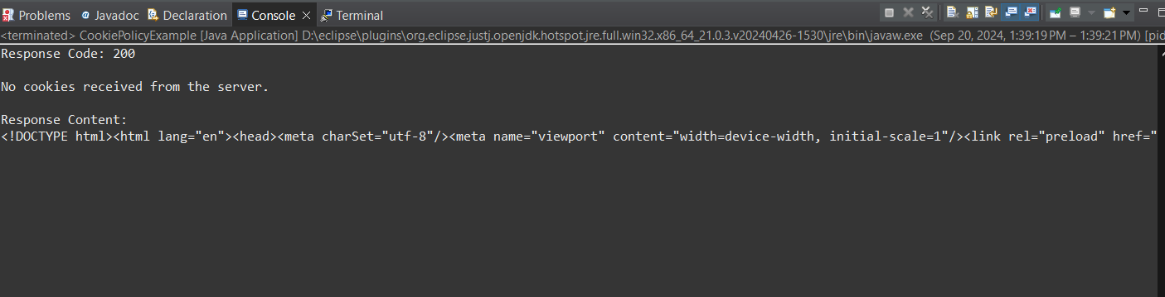

**Discussion:**

In this program, the HttpURLConnection class is used to send an HTTP GET request to a given URL. The response headers are analyzed to extract any cookies sent by the server. A check is then performed on the domain of the server, and cookies from .gov domains are blocked. This approach showcases a simple but effective way to implement cookie policy logic in Java.

**Conclusion**:

The solution provided effectively demonstrates a way to block cookies from .gov domains in Java using network programming techniques. This can be expanded into more sophisticated cookie management and policy control mechanisms for broader applications.

**LAB 4: URL Connection**

**Question no: 1**

**Title:**

Write a program to download a web page with the correct character set.

**Source Code:**

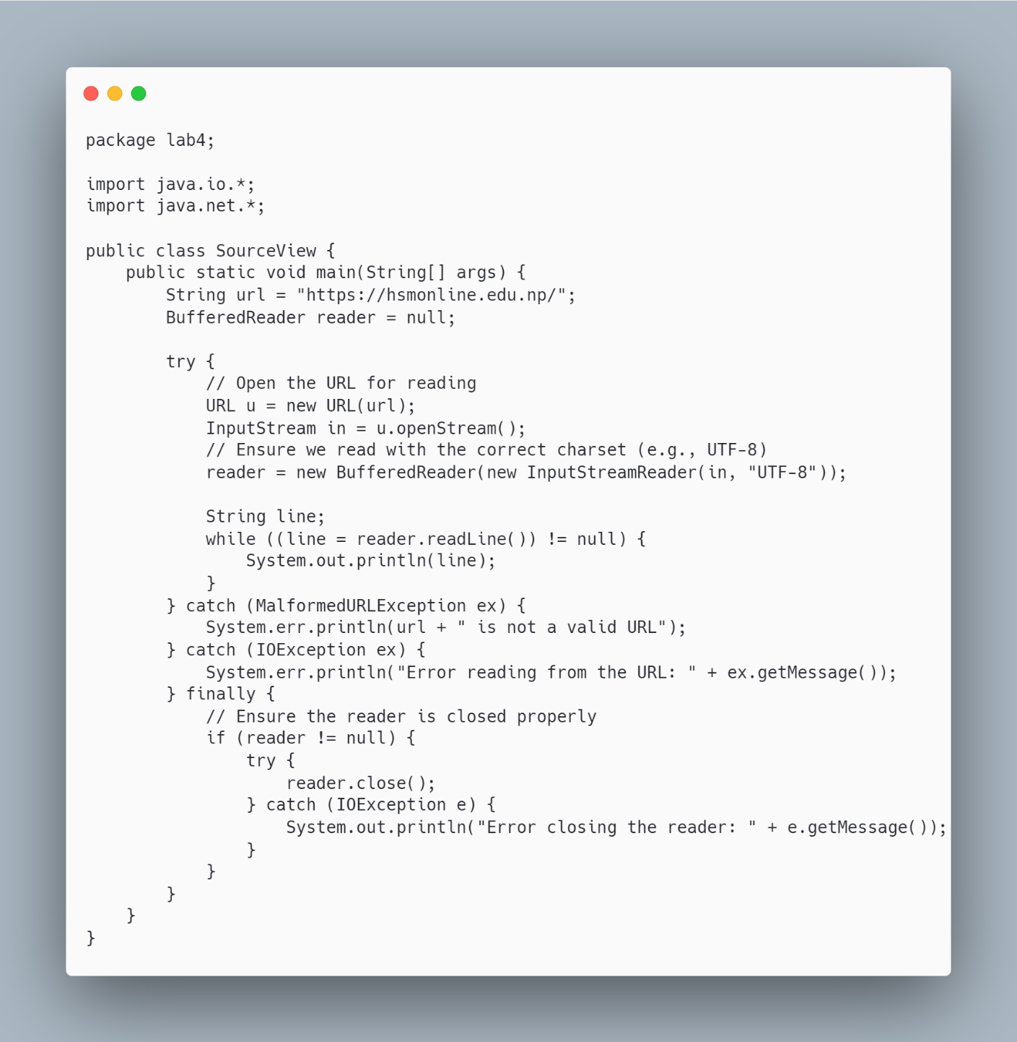

**Output:**

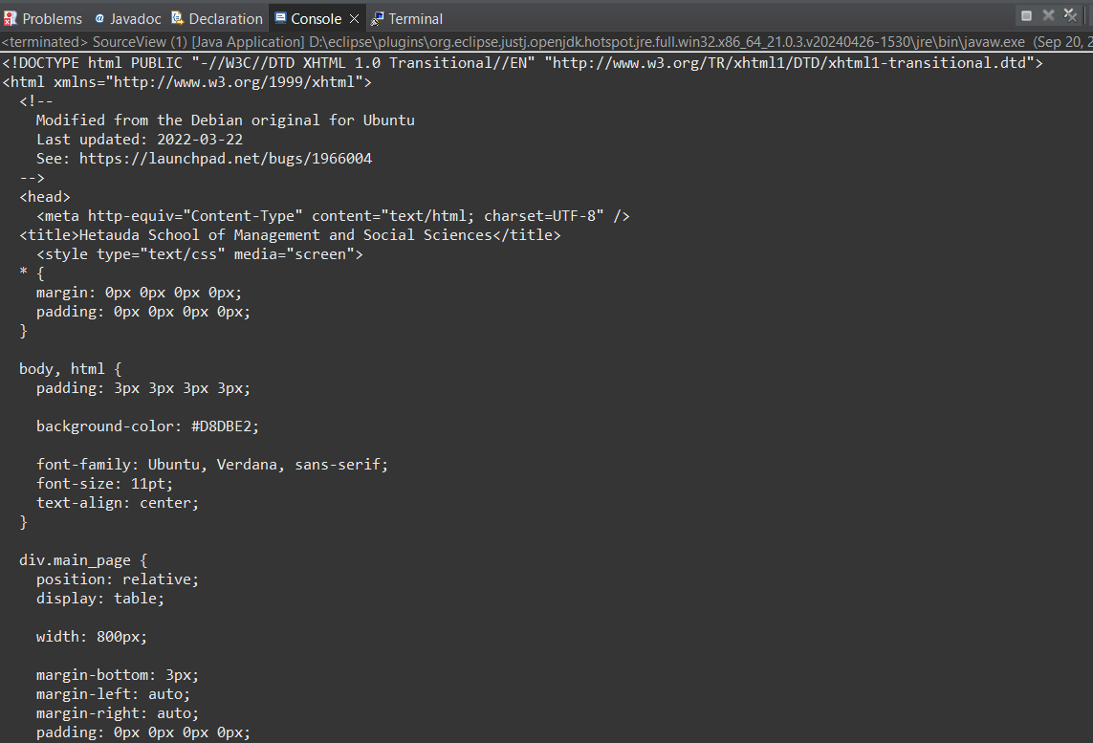

**Discussion:**

The program initiates an HTTP request to the specified URL and retrieves the server's response. Typically, the character encoding used by the web page is embedded in the `Content-Type` header of the HTTP response. If this information is not provided by the server, the program defaults to using UTF-8, which is a widely adopted standard for encoding. By ensuring the correct character set is used, the program accurately reads and displays the content, including non-ASCII characters such as accented letters and special symbols. Proper handling of character encodings is crucial in web development, particularly when working with multilingual websites or content that includes special symbols, as it ensures the content is rendered accurately across various browsers and platforms.

**Conclusion**:

This Java program effectively demonstrates how to download and print the source of a web page. It provides a foundation for more advanced tasks, such as processing HTML, scraping data, or saving web pages to files. Proper error handling and character encoding ensure that it works robustly across various web pages.

**Question no: 2**

**Title:**

Write a program to read different Header fields.

**Source Code:**

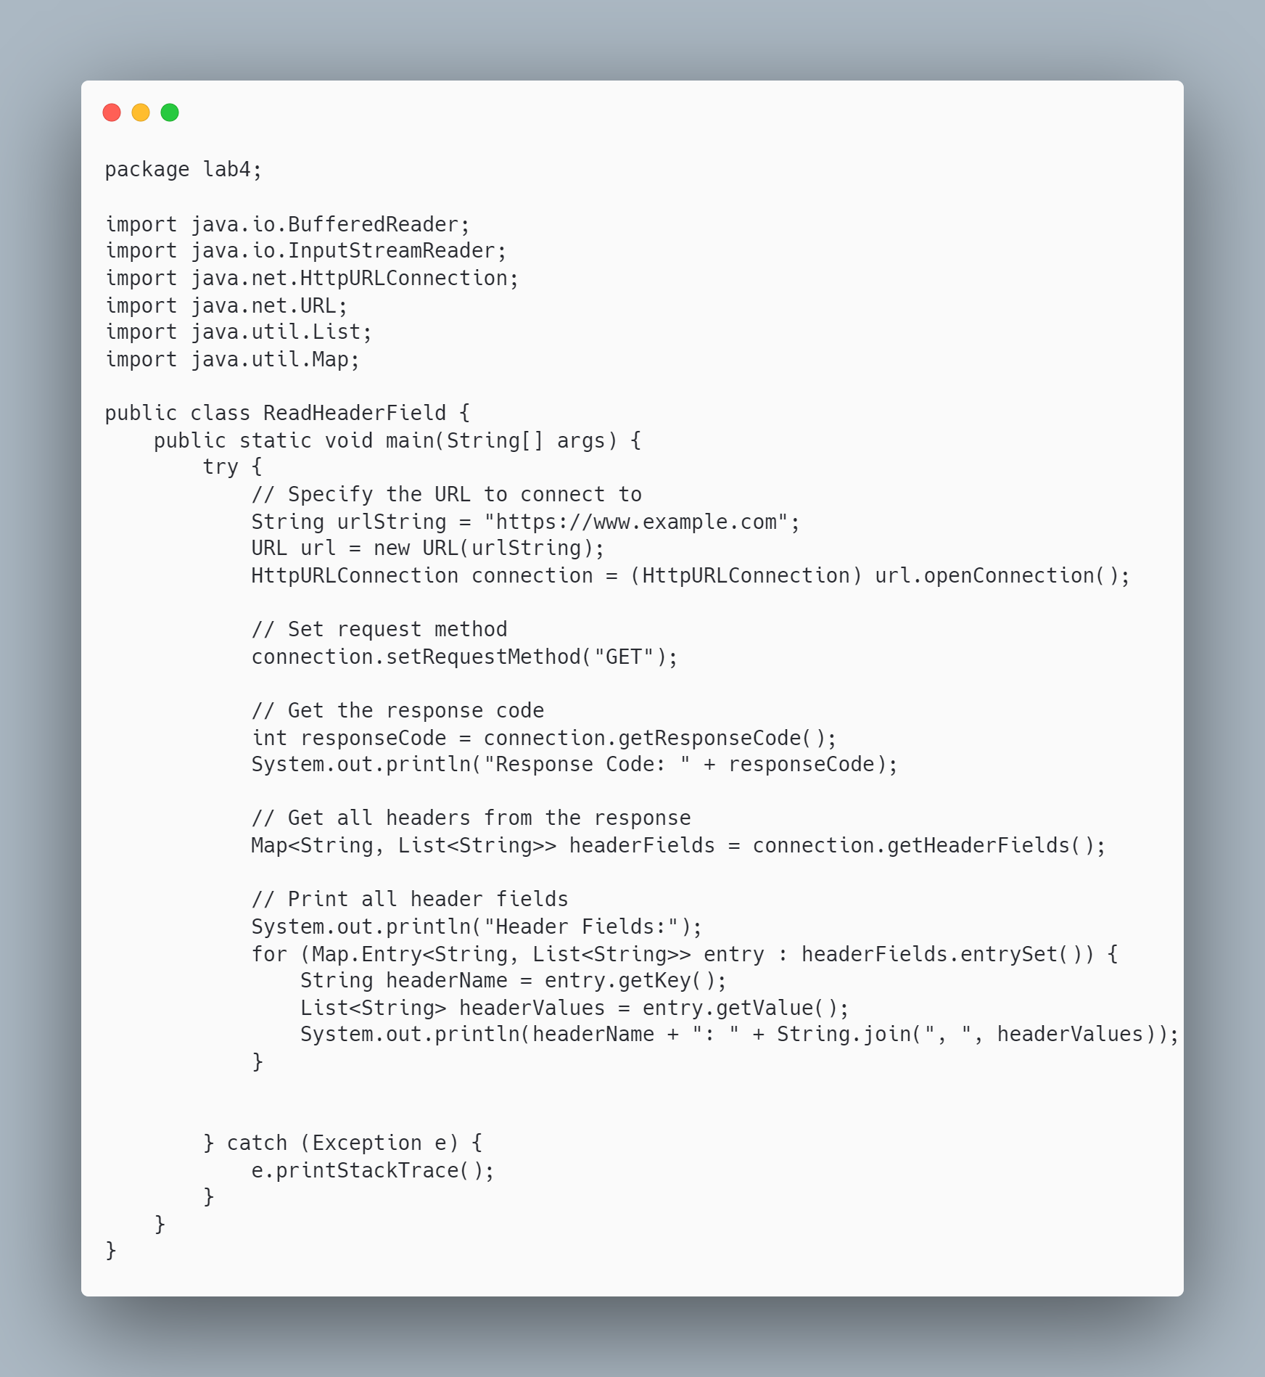

**Output:**

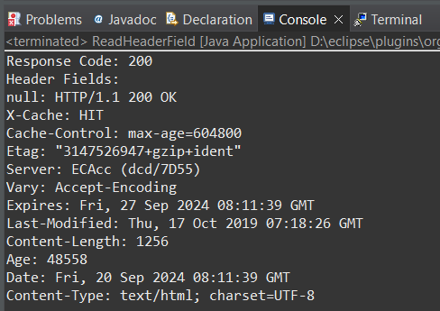

**Discussion:**

The program demonstrates how to retrieve HTTP header fields, which provide important metadata about the response from the server. Header fields such as Content-Type indicate the format of the data, Server shows the server technology in use, and other fields may provide information about cookies, caching, and more. These headers are essential for understanding how to process the data received and for diagnosing issues with HTTP requests.

**Conclusion**:

This program successfully retrieves and prints all HTTP header fields from the server's response. By accessing these headers, developers can gain insights into how the server operates and how the content should be processed. Understanding header fields is fundamental in network programming, especially in scenarios like API development, web scraping, and client-server communication.

**Question no: 3**

**Title:**

Write a program to get the time when a URL was last changed.

**Source Code:**

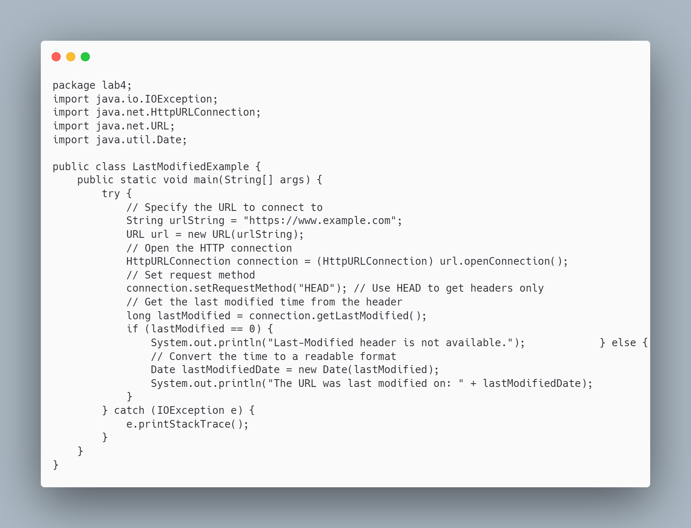

**Output:**

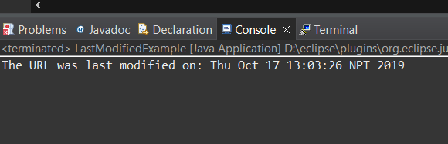

**Discussion:**

The program demonstrates how to retrieve HTTP header fields, which provide important metadata about the response from the server. Header fields such as Content-Type indicate the format of the data, Server shows the server technology in use, and other fields may provide information about cookies, caching, and more. These headers are essential for understanding how to process the data received and for diagnosing issues with HTTP requests.

**Conclusion**:

This program successfully retrieves and prints all HTTP header fields from the server's response. By accessing these headers, developers can gain insights into how the server operates and how the content should be processed. Understanding header fields is fundamental in network programming, especially in scenarios like API development, web scraping, and client-server communication.

**LAB 5: Socket Programming**

**Question no: 1**

**Title:** Create a console application to send and receive a message to and from server.

**Source Code:**

Server  
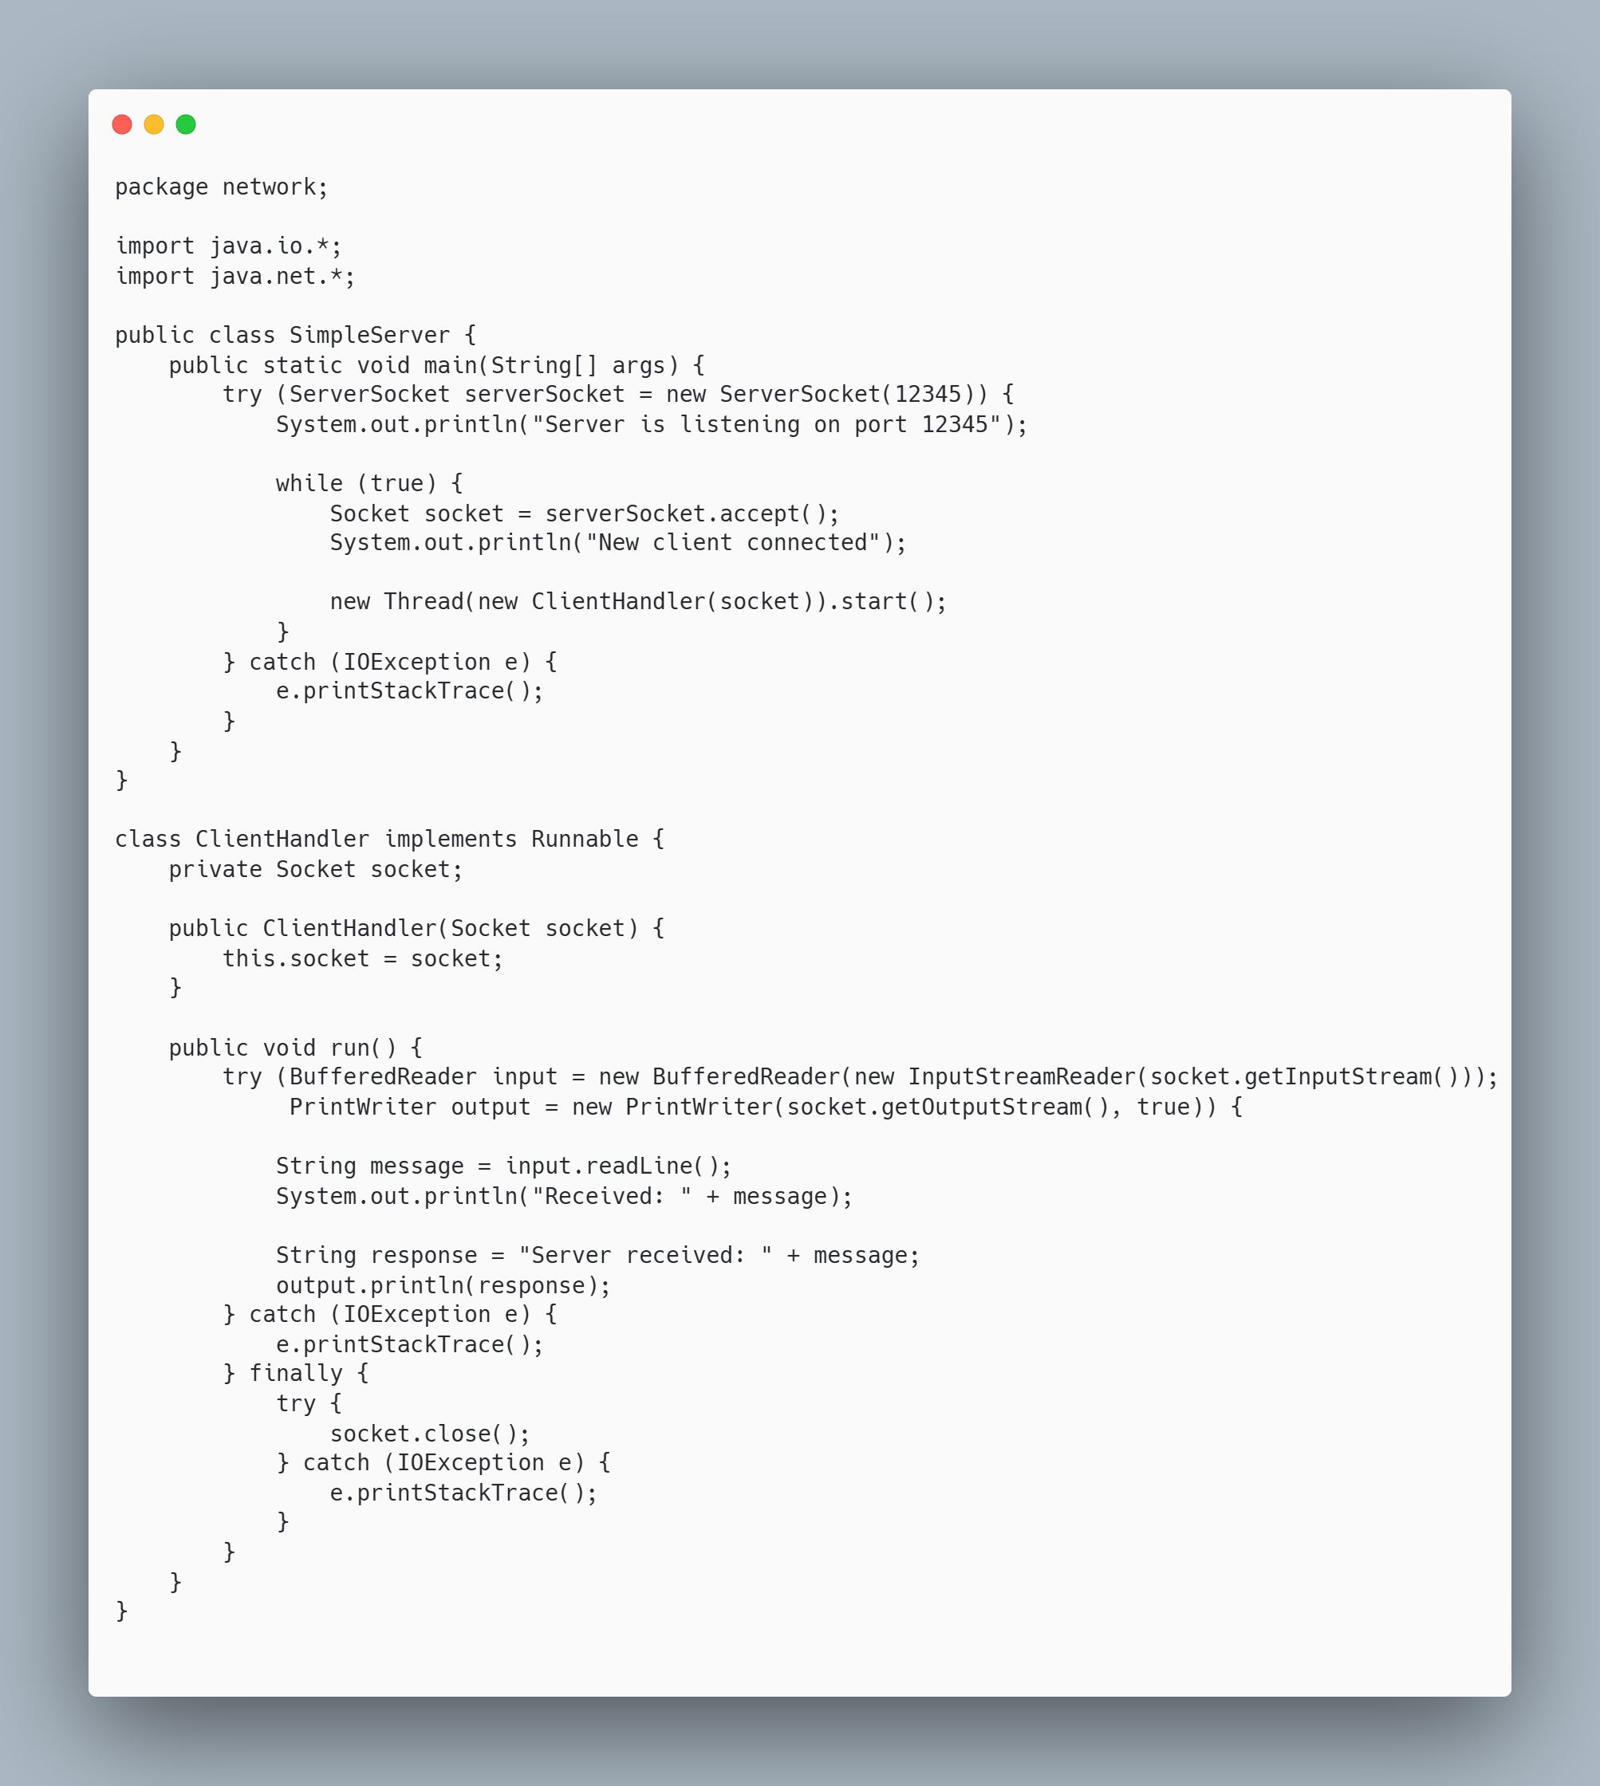

Client

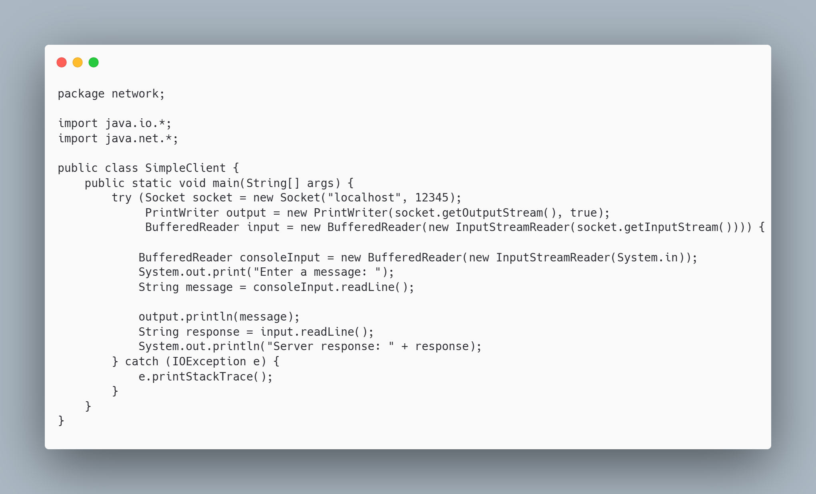

**Output:**

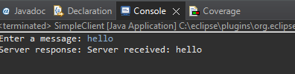

**Discussion:**

This console application demonstrates fundamental client-server communication using Java Sockets. The server is set up to listen for incoming connections on a specified port and can handle multiple clients simultaneously by spawning a new thread for each connection. The client can send a message to the server and receive a response, showcasing the bi-directional communication capabilities of sockets. This setup is commonly used in network programming and forms the basis for various applications, including chat systems, remote procedure calls, and real-time data exchange..

**Conclusion**:

The implementation of a simple client-server architecture highlights the ease of establishing network communication in Java using Sockets. This program effectively illustrates how to send and receive messages, demonstrating both server-side handling of client requests and client-side interaction. By understanding these principles, developers can build more complex networked applications that facilitate communication between different systems, paving the way for advanced functionalities such as multi-user chat applications, distributed systems, and client-server architectures in enterprise solutions.

**Question no: 2**

**Title:** Create a GUI chat application using Swing.

**Source Code:**

Server

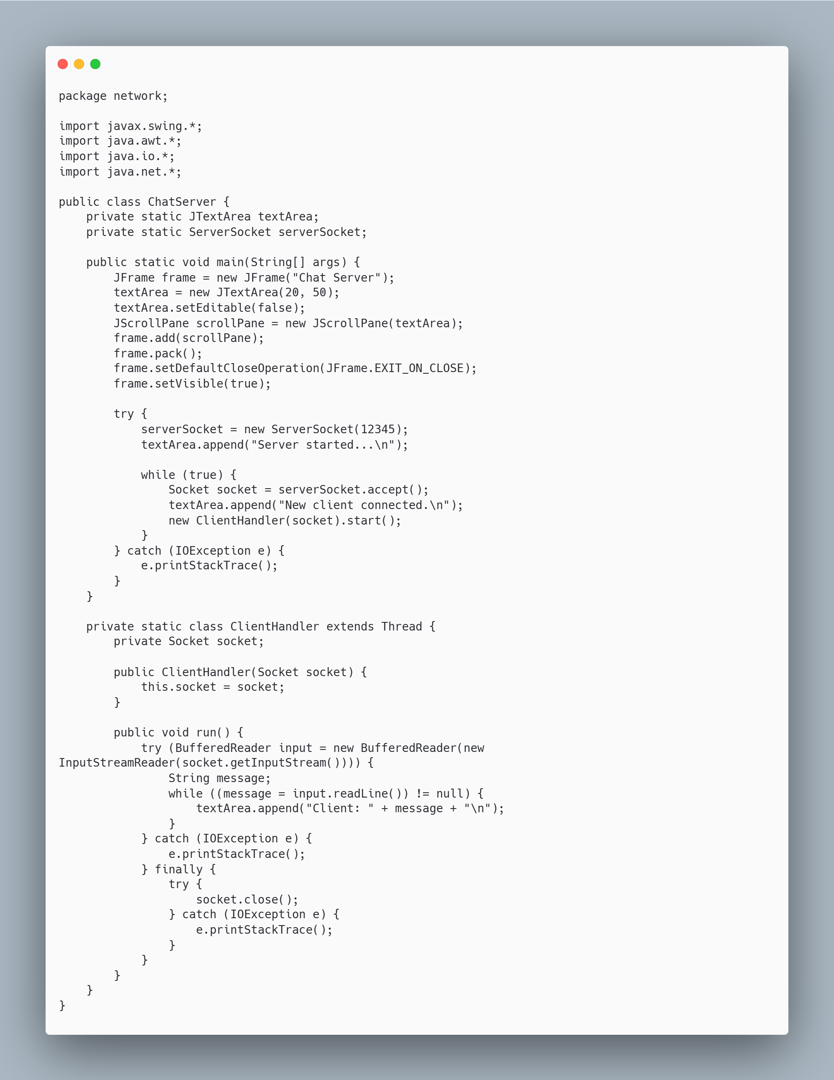

Client

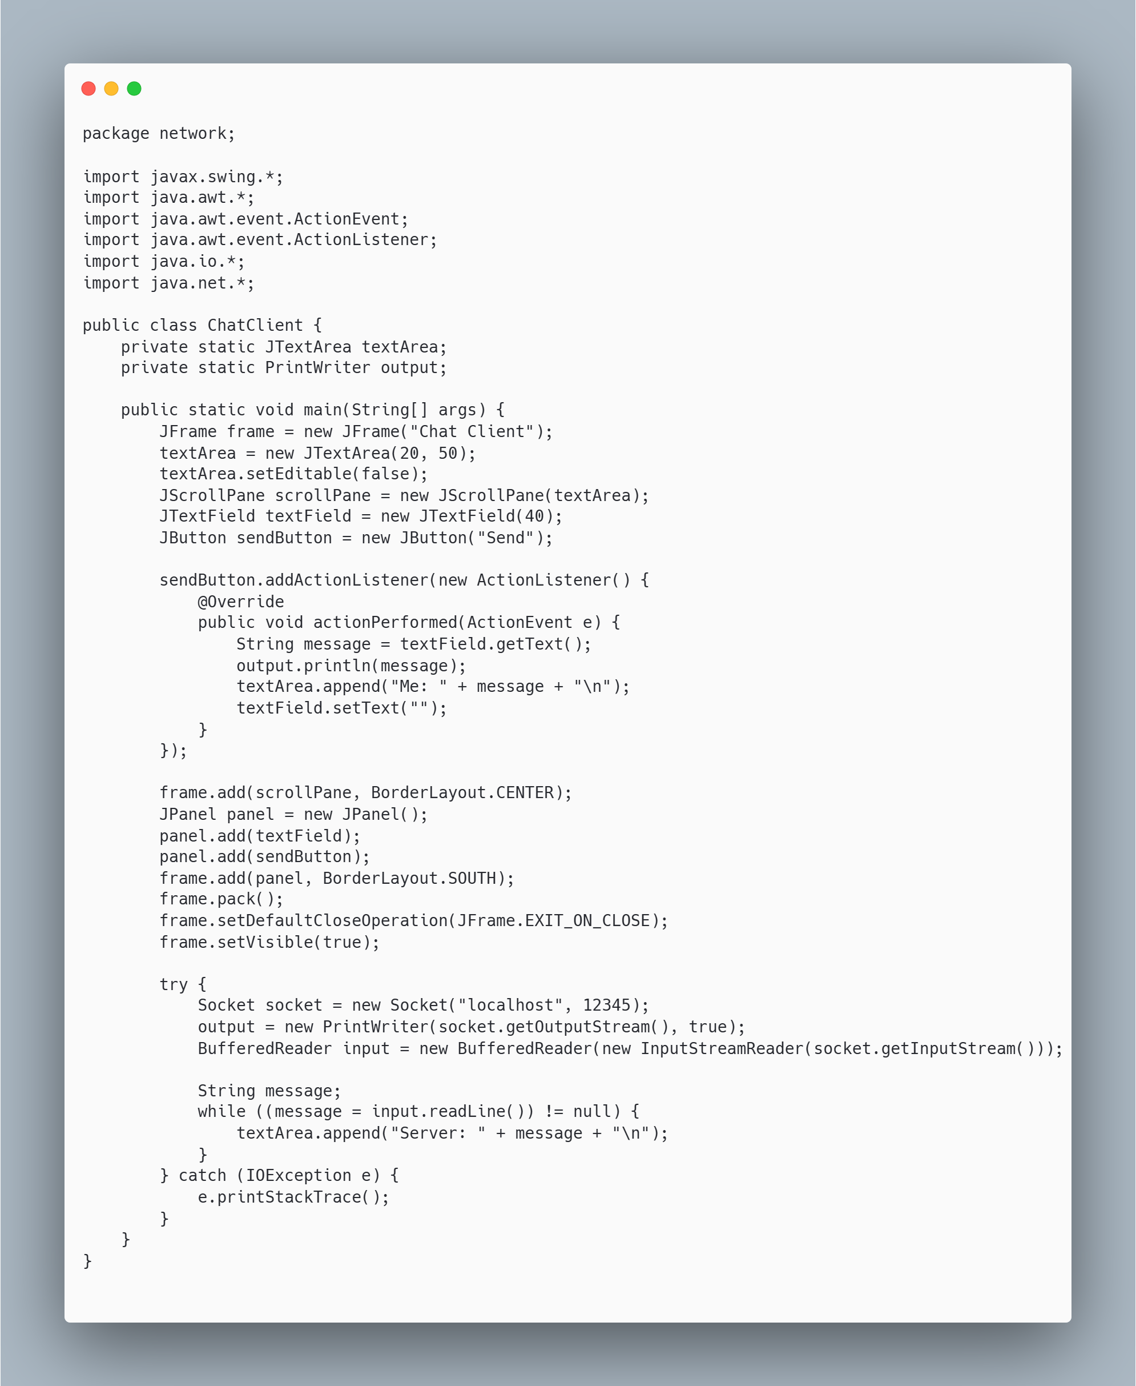

**Output:**

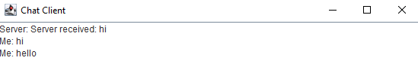

**Discussion:**

The GUI chat application demonstrates the fundamental concepts of client-server communication using Java Swing for the graphical interface and Java Sockets for network connectivity. The server operates on a specified port, accepting multiple client connections and processing messages concurrently through threading. The client interface allows users to send messages to the server, which are then displayed in a text area, facilitating real-time communication. This architecture effectively illustrates how to manage network connections, handle concurrent user interactions, and implement a simple yet functional messaging system**.**

**Conclusion**:

This application successfully showcases the capabilities of Java in creating interactive networked applications with a graphical user interface. By leveraging Swing for the front-end and Sockets for backend communication, the project exemplifies the process of building a basic chat application. The design allows for easy expansion, such as adding features like user authentication, message logging, or enhanced error handling. Overall, this project provides a solid foundation for understanding client-server architecture and GUI development in Java, serving as a stepping stone for more complex applications in the future

**Question no: 3**

**Title:** Write a program to implement Datagram Socket in a console-based chat program.

**Source Code:**

Server

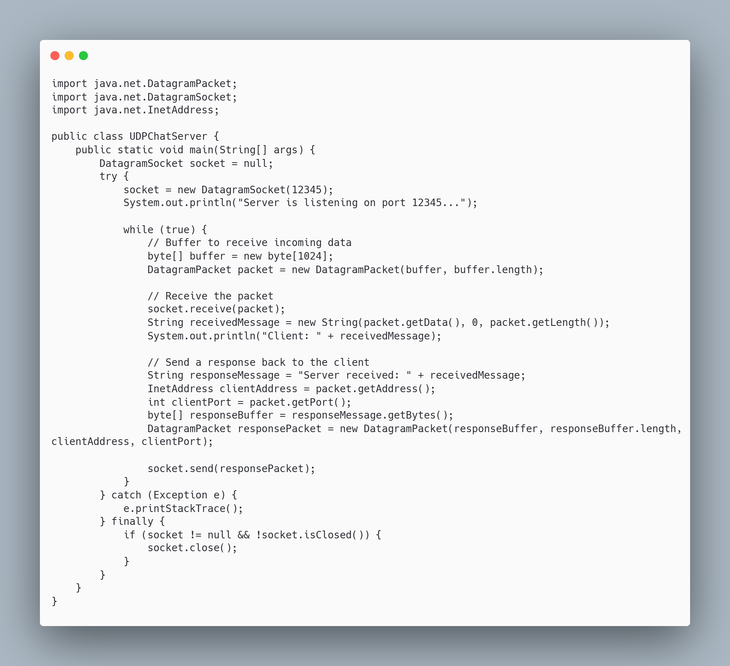

Client

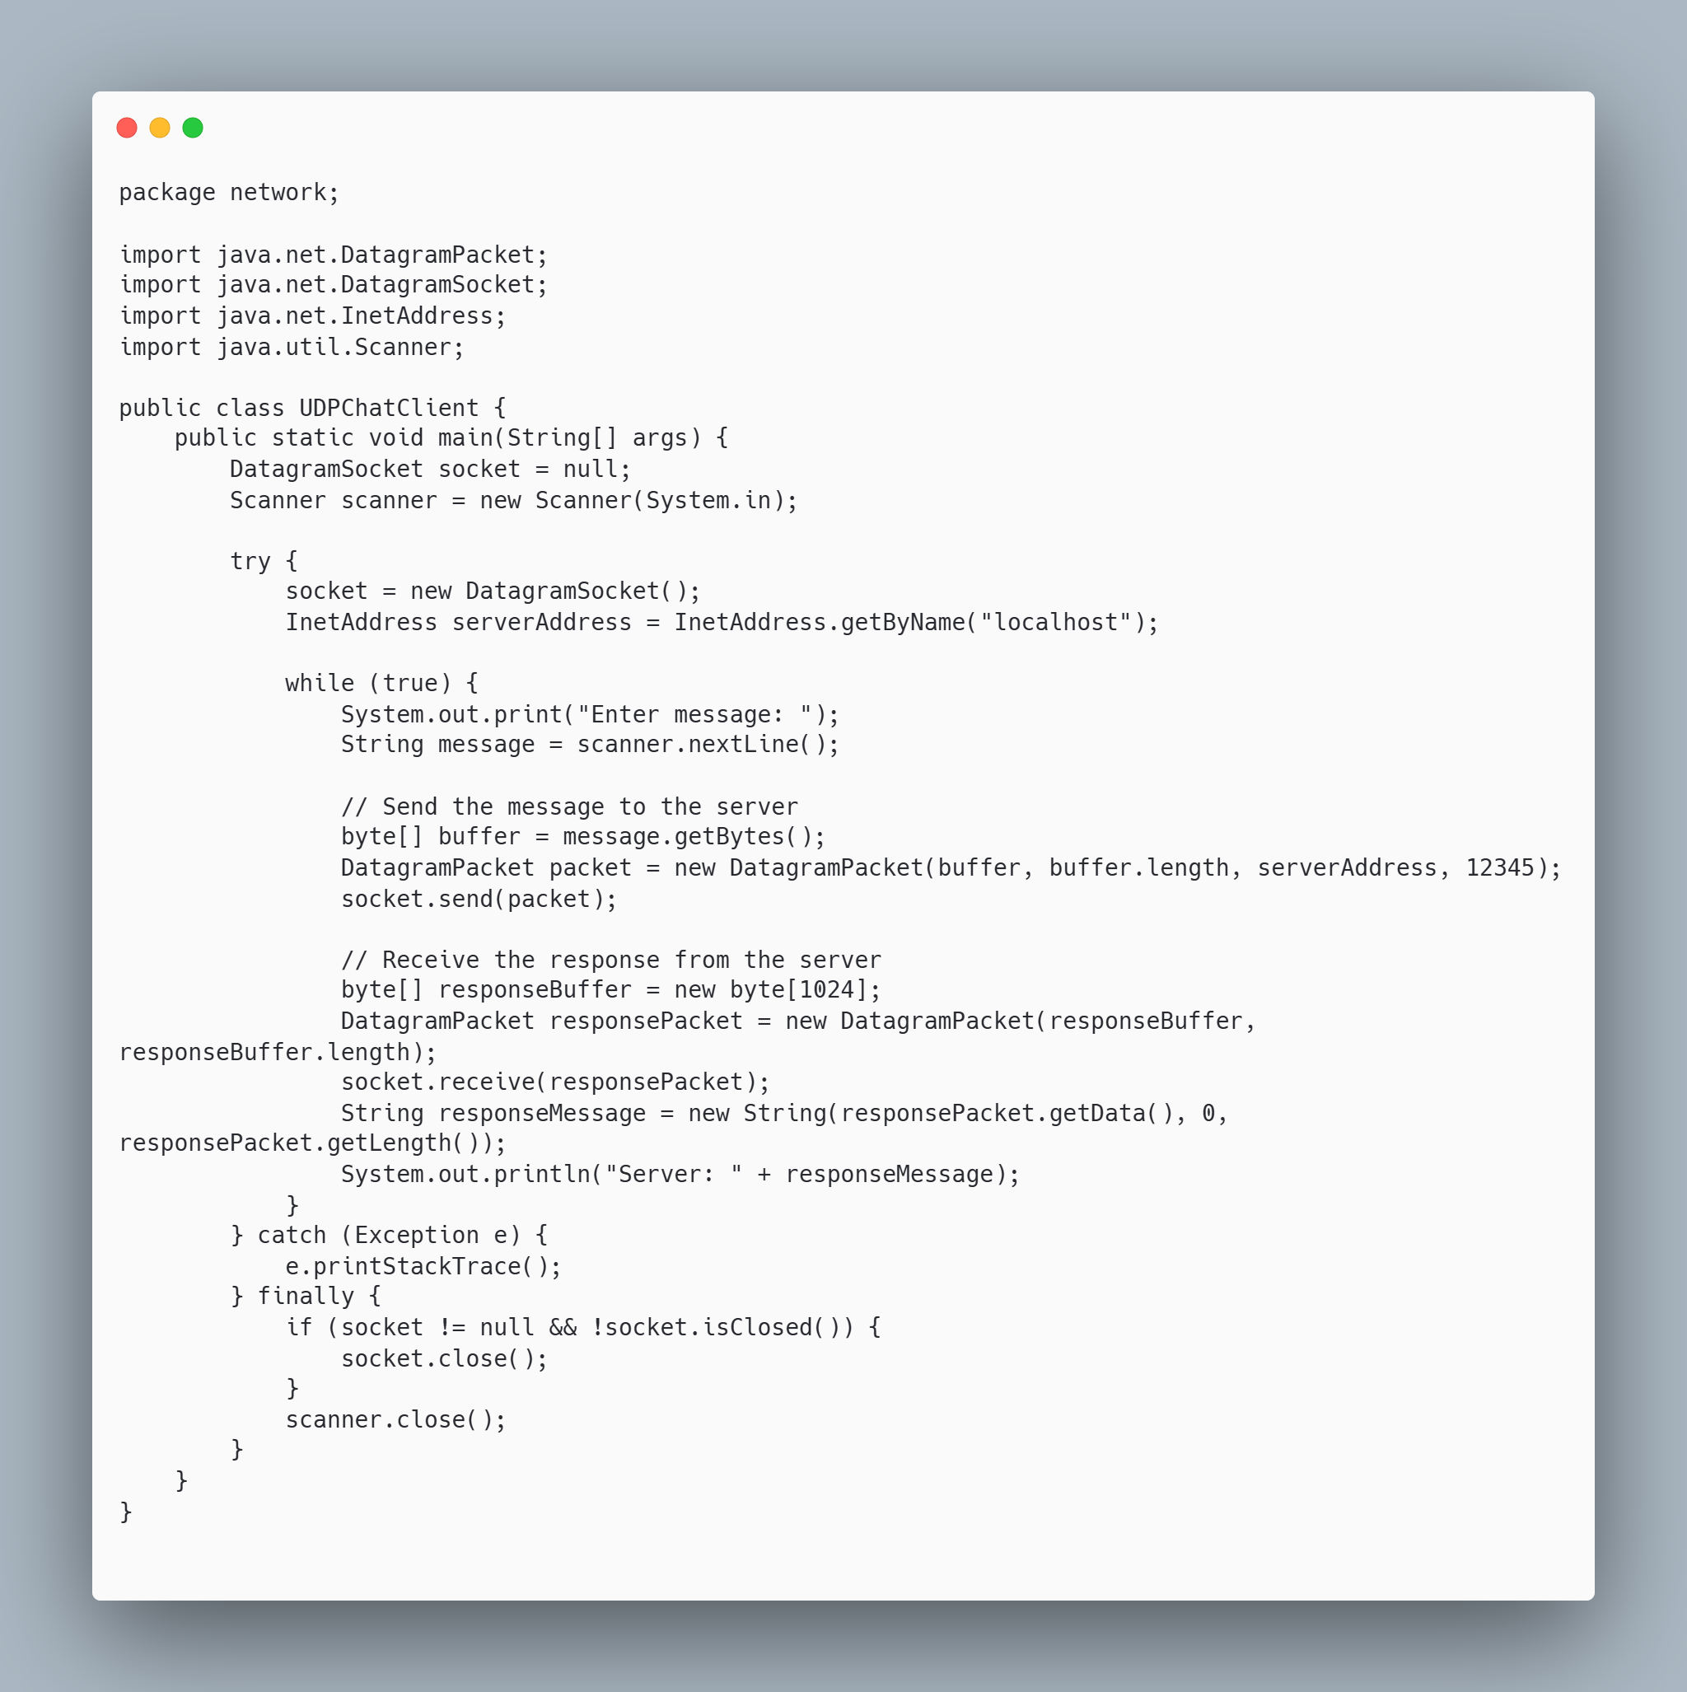

**Output:**

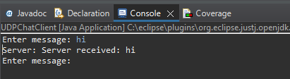

**Discussion:**

The implementation of a console-based chat program using Datagram Sockets showcases the basic principles of UDP communication in Java. Unlike TCP, UDP provides a connectionless protocol that allows for faster message transmission without the overhead of establishing and maintaining a connection. This makes it suitable for applications where speed is critical, although it does not guarantee message delivery or order. The server is capable of receiving messages in a loop, demonstrating how to handle incoming data packets. The client sends messages to the server and receives responses, illustrating the bi-directional communication typical of chat applications. This setup allows for real-time interactions, making it an excellent foundation for more complex networking applications.

**Conclusion**:

This chat program effectively demonstrates the use of Java Datagram Sockets for creating a simple UDP-based communication system. It highlights the key differences between UDP and TCP, particularly the trade-off between speed and reliability. The basic structure provided can serve as a stepping stone for more advanced applications, such as implementing error handling, message acknowledgment, and user authentication. Overall, this program illustrates how to achieve efficient communication in a networked environment, offering insights into the practical applications of socket programming in Java.

**Question no: 4**

**Title:** Write a Multithreaded Daytime Server and Client application.

**Source Code:**

Server

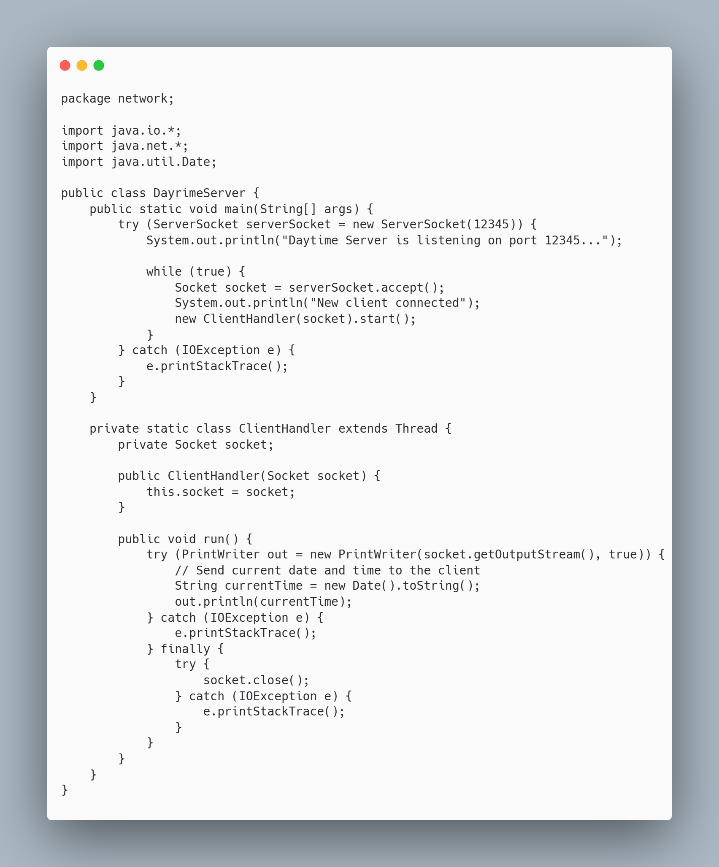

Client

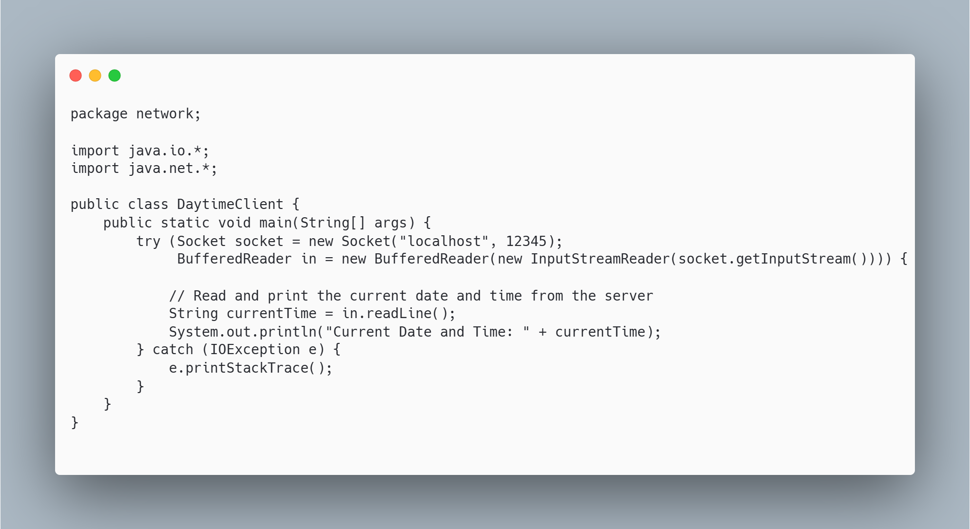

**Output:**

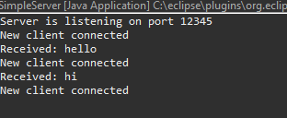

**Discussion:**

The multithreaded Daytime Server and Client application illustrates the core concepts of socket programming and concurrency in Java. The server utilizes multithreading to handle multiple client connections simultaneously, ensuring that each client receives the current date and time without delays. This design is efficient and scalable, allowing the server to serve many clients at once. The use of ServerSocket for listening and Socket for communication exemplifies the client-server architecture, while the threads manage client interactions independently, providing a responsive user experience. This approach can be beneficial in various real-world applications where timely responses are crucial.

**Conclusion**:

This Daytime Server and Client application serves as a practical example of implementing a multithreaded server in Java. By leveraging sockets and threads, the application effectively demonstrates how to manage concurrent client requests, ensuring each client receives the desired information promptly. This foundational understanding of socket programming and multithreading can be applied to develop more complex applications, such as chat servers, real-time data processing systems, and web servers. Overall, this project highlights the importance of concurrency in network programming and provides a solid basis for further exploration into networked applications.

**LAB 6: NIO, IP Multicasting and RMI**

**Question no: 1**

**Title:**

Write a program that shows IP multicasting server and Clients.

**Source Code:**

Server

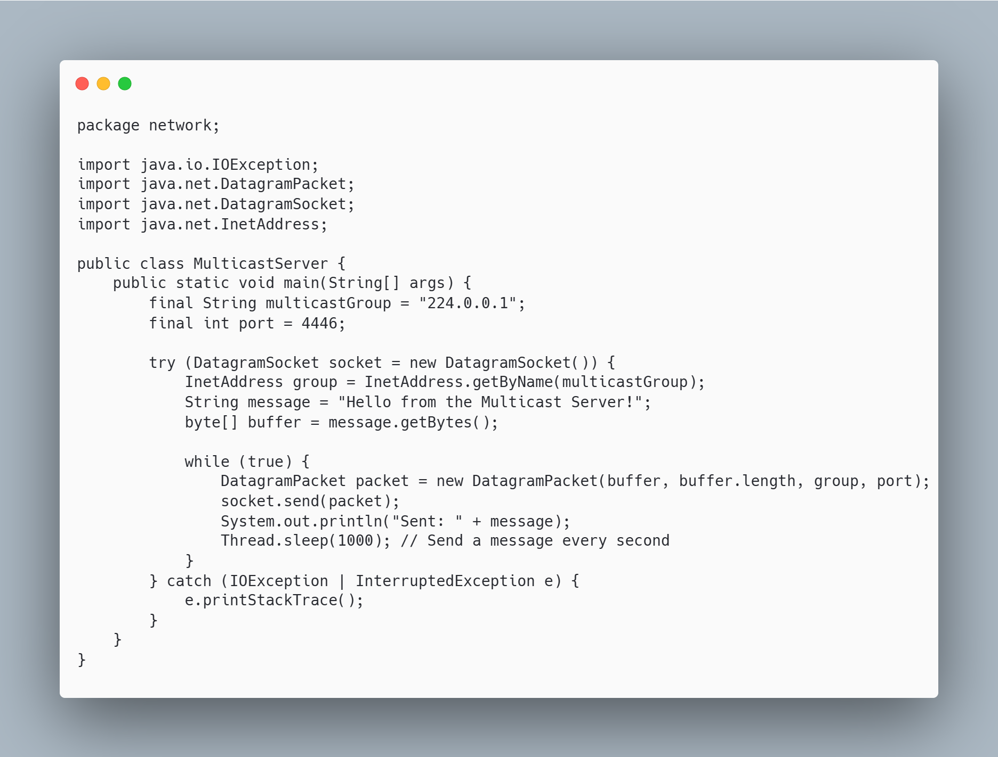

Client  
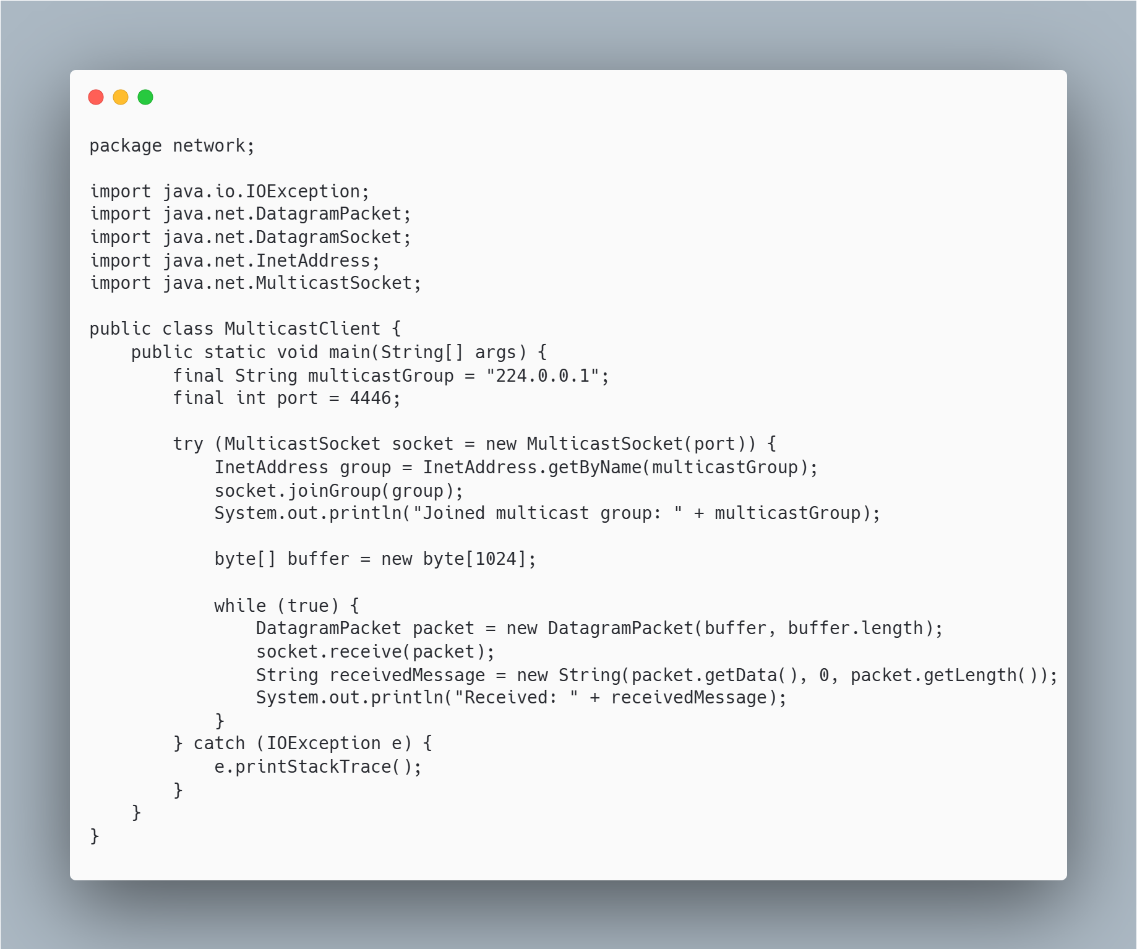

**Output:**

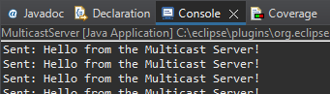

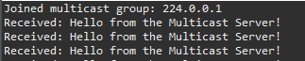

**Discussion:**

Multicasting is an efficient communication method used in scenarios where data needs to be distributed to multiple clients at the same time, such as in video streaming, stock price updates, or live event broadcasting. In this program, the server broadcasts a message to a multicast group, and all clients that have joined this group receive the message simultaneously. This avoids the need for the server to send the same message individually to each client, reducing network traffic.

Multicasting requires the use of a specific range of IP addresses and the clients must explicitly join the group to receive messages. The program also demonstrates the use of MulticastSocket for both sending and receiving data.

**Conclusion**:

This program demonstrates how IP multicasting can be used to send messages from a server to multiple clients efficiently. By using a multicast group, the server sends a single message, which is received by all the clients that are members of the group. This method is particularly useful in scenarios where real-time data needs to be delivered to multiple users simultaneously.

**Question no: 2**

**Title:**

Write a program using RMI where a server is registered with a method that adds two number. Another program in different machine calls the method in the remote server to add two numbers.

**Source Code:**

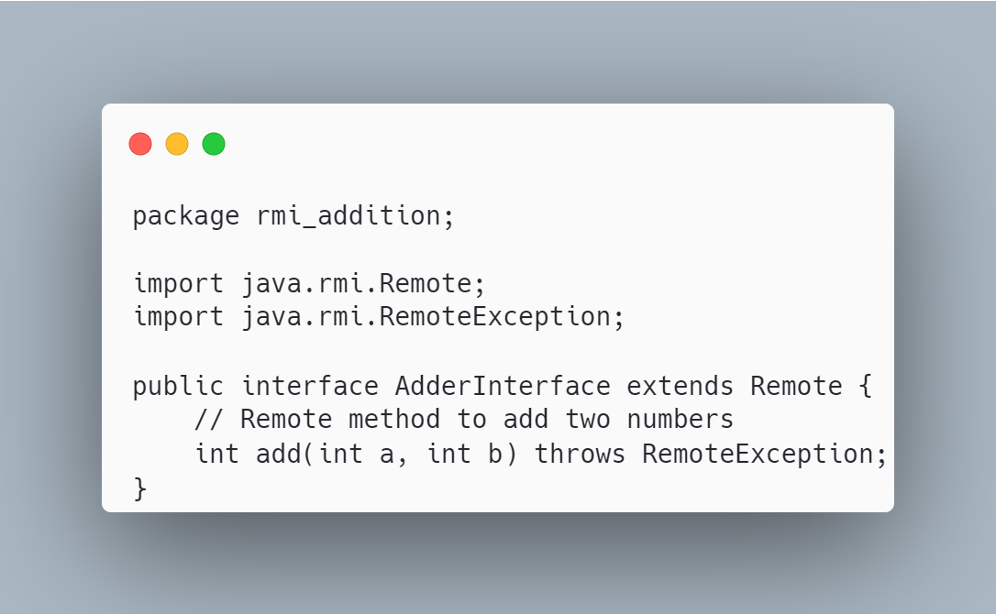

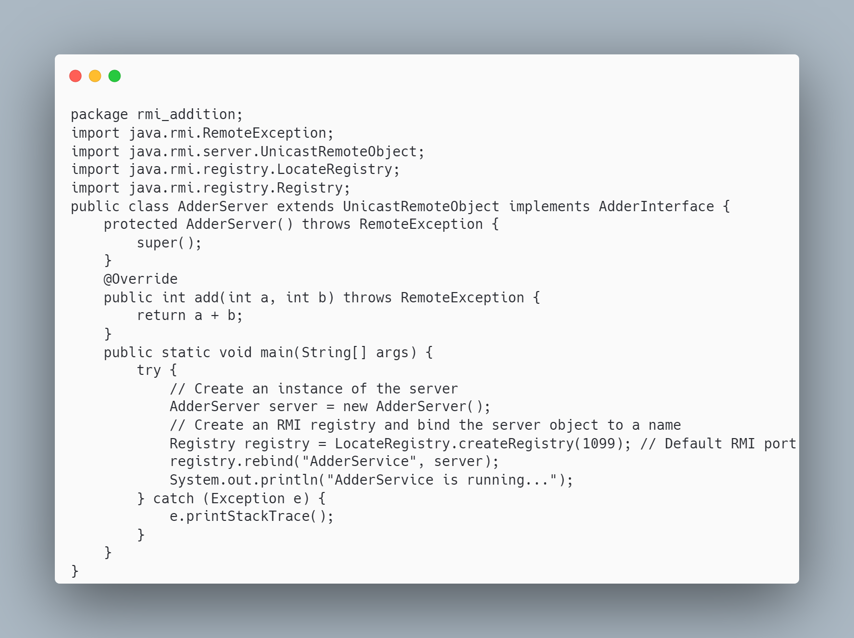

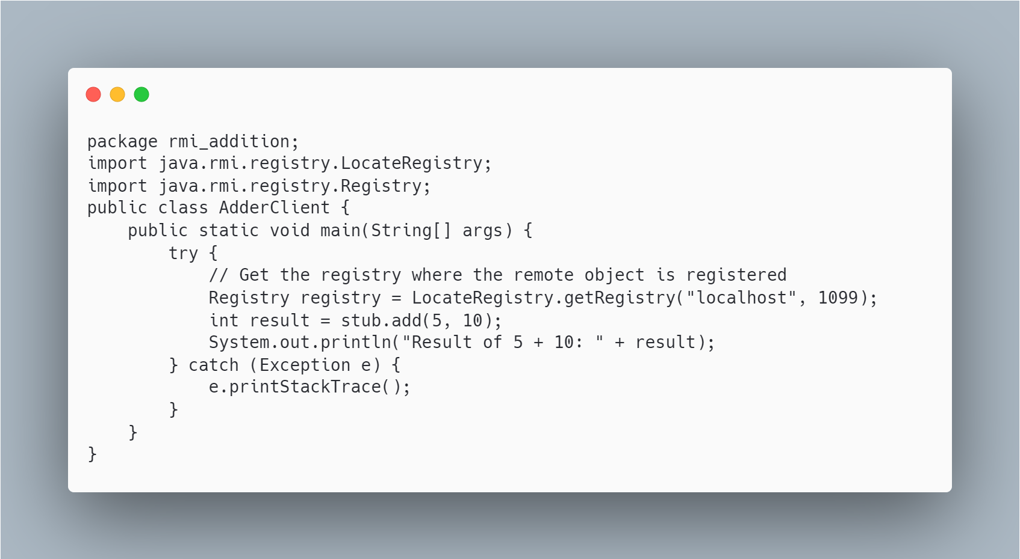

**Output:**

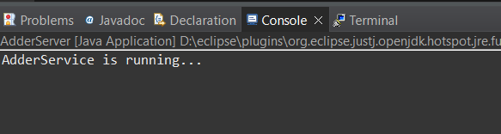

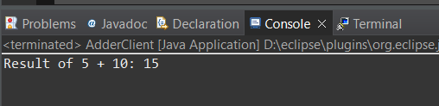

**Discussion:**

This RMI application demonstrates how remote method invocation works in Java. The server registers a remote object with the RMI registry, and the client retrieves this object to invoke its method. The client doesn't need to know where the server is physically located; it only needs the server's IP and the name of the remote service.

Java RMI abstracts the underlying network communication, making it easier to implement distributed applications. The method invocation works in the same way as local method calls, except that the client and server can be on different machines.

**Conclusion**:

Java RMI is an effective tool for building distributed applications where methods can be invoked on remote servers. In this example, the client was able to call a method on a remote server to add two numbers. This type of architecture is useful for scenarios where multiple clients need to interact with a central server to perform tasks.

**Question no: 3**

**Title:**

Write a socket program using channel and selector to perform communication between client and server.

**Source Code:**

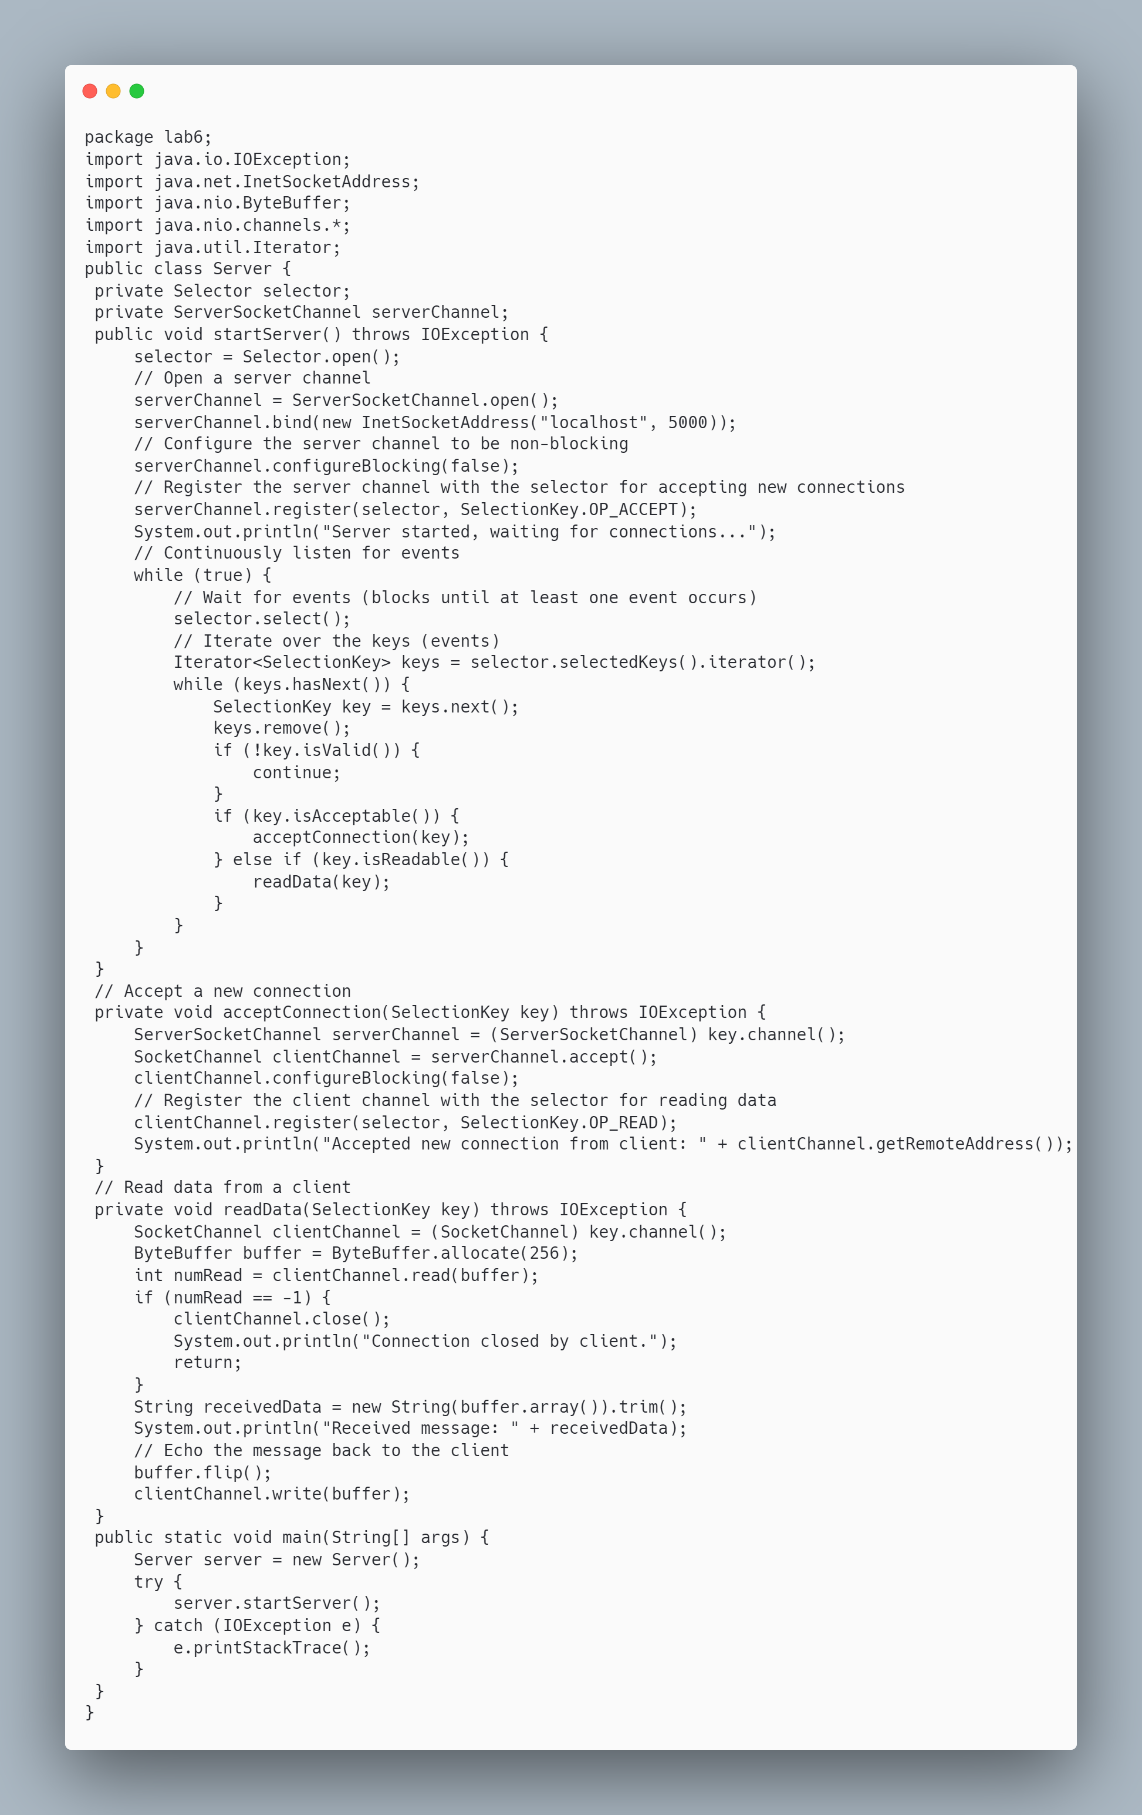

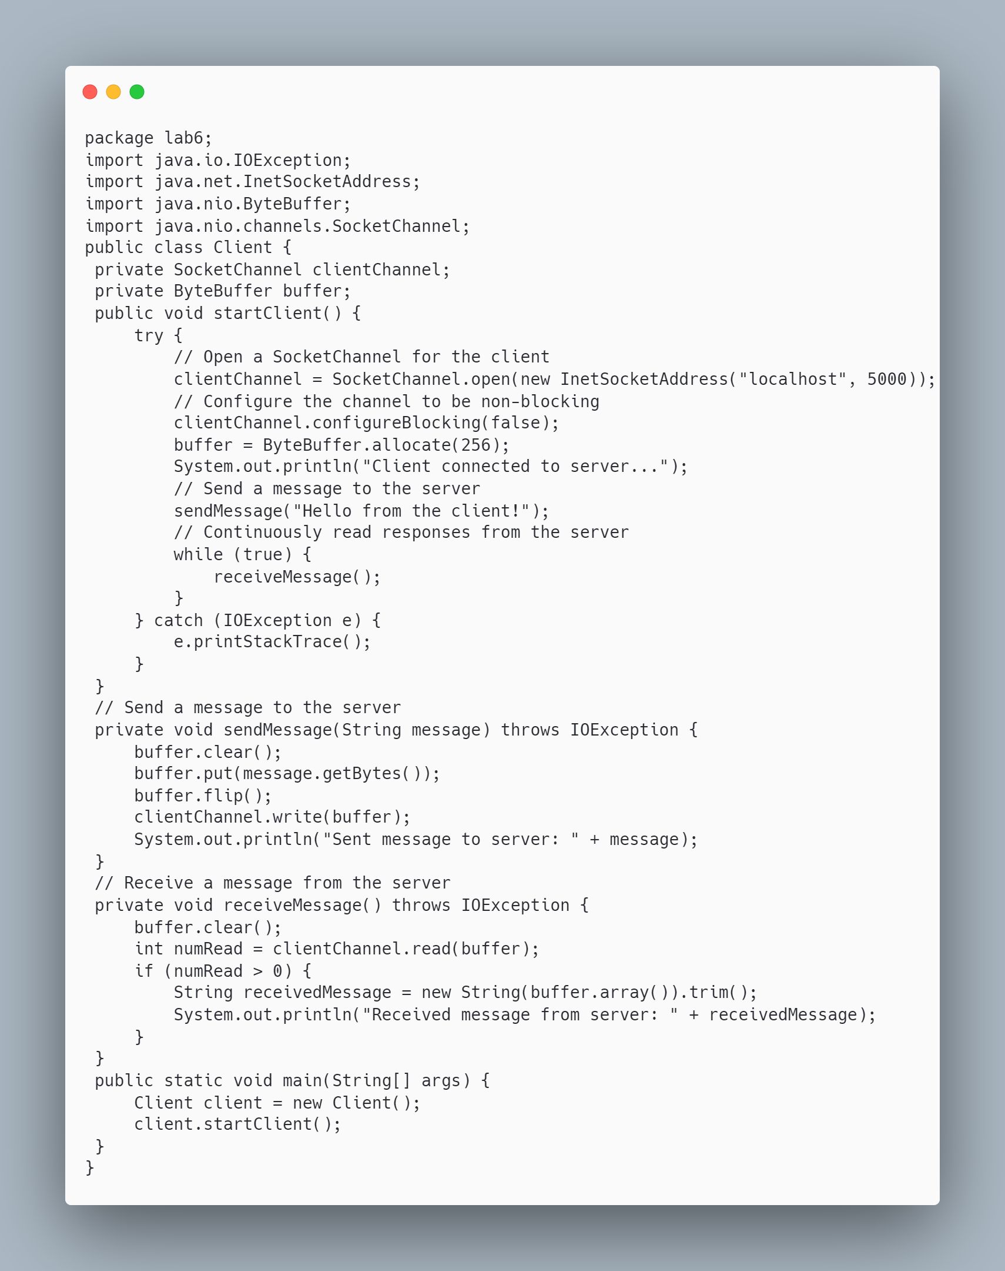

**Output:  
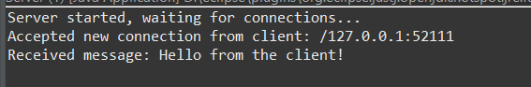**

**Discussion:**

This program uses Java NIO to create a scalable client-server application. The server uses a selector to manage multiple clients without requiring multiple threads, making the server efficient even with many connections. Channels are used for communication, and the use of non-blocking I/O allows the server to serve multiple clients simultaneously without being blocked by any single connection.

**Conclusion**:

Using Java NIO with Channels and Selectors is an efficient way to handle multiple client connections in a non-blocking manner. The server can manage several clients using a single thread, making the architecture scalable and suitable for high-performance applications.